

Card Play

Project Documentation

By:

Harsh Subhash Rajput

Seat No: 1906856

And

Darshan Sanjay Mishra

Seat No: 1906840

Class: T.Y. BSc.IT (2019-2020)

**K. J. SOMAIYA COLLEGE OF SCIENCE AND COMMERCE**

**Re-accredited with 'A' Grade by NAAC**

Vidyanagar, Vidyavihar, Mumbai 400 077

**DEPARTMENT OF INFORMATION TECHNOLOGY**

**PROJECT CERTIFICATE FOR B.Sc. (I.T.) STUDENTS**

**2019 – 2020**

*This is to certify- that the project entitled*

**CardPlay**

*Undertaken by*

*Brother* **HARSH SUBHASH RAJPUT (Seat no: 1906856)**

*Brother* **DARSHAN SANJAY MISHRA (Seat no: 1906840)**

*in fulfilment for B.Sc I.T. Degree(Semester 6) Examination has been completed by him/her. This project had not been submitted for any other examination and does not form a part of any other course undergone by the candidate.*

*This is to further certify that he/she has completed all required phases of the project.*

*________________________ ________________________*

( Mrs. Prajakta Kamble ) ( Mr. Prakash Patil)

Project Guide Head of the Department

*________________________*

College Seal External Examiner

**ABSTRACT**

The business-to-consumer aspect of product commerce (e-commerce) is the most visible business use of the World Wide Web. The primary goal of an e-commerce site is to sell goods online.

This project deals with developing an e-commerce website for Online Product Sale. It provides the user with a catalog of different product available for purchase in the store.

In order to facilitate online purchase a shopping cart is provided to the user. The system is implemented using a single-tier approach, with a backend database PHP, and a web browser as the front end client. In order to develop an e-commerce website, a number of Technologies must be studied and understood.

These include server and client side scripting techniques, implementation technologies such as PHP (OOP), JQUERY, BOOTSTRAP and HTML5. This is a project with the objective to develop a basic website where a consumer is provided with a shopping cart application and also to know about the technologies used to develop such an application. This document will discuss each of the underlying technologies to create and implement an e-commerce website.

**ACKNOWLEDGEMENT**

Prior to initiating the in-depth analysis our project “CardPlay” website, we would like to express our deepest gratitude and appreciation for all the people who given an unending support in completing this graduate project for which we have been fortunate to have help, support and encouragement from many people. We would like to acknowledge them for their cooperation.

Firstly, I would like to acknowledge the support showered by our head of department of information technology, **Mr. PRAKASH PATIL** and all the respected teachers who gave us their valuable knowledge and their ideologies which helped us throughout the course of this project

We would like to thank **Mrs. PRAJAKTA KAMBLE**, our project advisor, for guiding us through each and every step of the process with knowledge and support. Thank you for your advice, guidance and assistance.

Finally, we would also like to thank **Ms. ANUSHREE SUKHI**, who showed immense patience and understanding throughout the project and provided suggestions.

Last but not the least my deepest gratitude and thanks goes to my family members as well as my friends for being co-operative whenever we needed any assistance in our project.

Contents

CHAPTER 1: INTRODUCTION 6

1.1 Background 6

1.2 Objectives 6

1.3 Purpose, Scope and Applicability 6

1.3.1 Purpose 6

1.3.2 Scope 6

1.3.3 Applicability 7

CHAPTER 2: SURVEY OF TECHNOLOGIES 8

CHAPTER 3: REQUIREMENTS AND ANALYSIS 9

3.1 Problem Definition 9

3.2 Requirement Analysis 9

3.3 Planning and Scheduling 9

3.4 Software and Hardware Requirements 10

3.5 Preliminary Product Description 10

3.6 Conceptual Models 11

CHAPTER 4: SYSTEM DESIGN 14

4.1 Basic Modules 14

4.2 Procedural Design 14

4.2.1 Logic Diagrams 14

4.3 User Interface Design 18

4.4 Security Issues 34

4.5 Test Cases Design 34

CHAPTER 5: IMPLEMENTATION AND TESTING 36

5.1 Implementation and Approaches 36

5.2 Coding Details and Code Efficiency 36

5.2.1 Code Efficiency 39

5.3 Testing Approach 39

5.3.1 Unit Testing 39

5.3.2 Integrated Testing 39

5.3.3 Beta Testing 39

5.4 Modifications and Improvements 39

CHAPTER 6: RESULTS AND DISCUSSION 40

6.1 Test Reports 40

6.2 User Documentation 40

CHAPTER 7: CONCLUSIONS 41

7.1 Conclusion 41

7.1.1 Significance of the System 41

7.2 Limitations of the System 41

7.3 Future Scope of then Project 41

REFERENCES: 42

# CHAPTER 1: INTRODUCTION

## 1.1 Background

E-commerce is fast gaining ground as an accepted and used business paradigm. More and more business houses are implementing web sites providing functionality for performing commercial transactions over the web. It is reasonable to say that the process of shopping on the web is becoming commonplace.

There are numerous websites which provide the option to buy cards online and provide customization as per their user’s satisfaction. But the core problem with these websites is that the user needs to spend in more of their time searching for their choice of selection of invite. Secondly the user interfaces of these websites are lengthy, resulting in making the user scroll throughout the site

## 1.2 Objectives

The main objective of this project is to make the process of buying and designing invites faster, making user interaction more interesting and reduce the time consumption. In other words, we can say that our project has the following objectives: -

● Make designing faster and better

● Reduce time consumption

● Reduce error scope

● Provide more convenient way to operate through website

## 1.3 Purpose, Scope and Applicability

### 1.3.1 Purpose

1. Make it easier to design and buy invitation cards
2. Reduce the time consumed to design and make a invite in physical world.
3. Provide a better user experience which is more informative and appealing to then user.

### 1.3.2 Scope

The project objective is to deliver the onlineshopping application to Computer using community and android platform. This project is an attempt to provide the advantages of onlineshopping to customers of a real shop. It helps buying the products in the shop anywhere through internet by using any browser over a device or an android device.

### 1.3.3 Applicability

1. Everyone can use this website for creating and buying cards.
2. Anyone can register onto the website.
3. The user who registers can buy and place an order for the invitation card of their choice.
4. The admin and staff can access the database to update and alter the product information or user details.
5. The admin can see what need to be updated and what are the queries from the users.
6. The admin can see all orders requested by registered users.
7. The admin is supposed to take queries regarding custom user requirements.

# CHAPTER 2: SURVEY OF TECHNOLOGIES

**❖ HTML**

Hypertext Mark-up Language (HTML) is the standard markup for documents designed to be displayed in a web browser. It can be assisted by technologies such as Cascading Style Sheets (CSS) and scripting languages such as JavaScript. Web browsers receive HTML documents from a web server or from local storage and render the documents into multimedia web pages. HTML describes the structure of a web page semantically and originally included cues for the appearance of the document.

**❖ PHP**

PHP is a server-side scripting language. That is used to develop Static websites or Dynamic websites or Web applications. PHP stands for Hypertext Preprocessor, that earlier stood for Personal Home Pages. PHP scripts can only be interpreted on a server that has PHP installed. The client computers accessing the PHP scripts require a web browser only.

**❖ AJAX**

**Ajax** (short for "Asynchronous JavaScript and XML") is a set of web development techniques using many web technologies on the client side to create asynchronous web applications. With Ajax, web applications can send and retrieve data from a server asynchronously (in the background) without interfering with the display and behavior of the existing page.

**❖ SQL Database**

SQL stands for Structured Query Language. SQL is used to communicate with a database. According to ANSI (American National Standards Institute), it is the standard language for relational database management systems. SQL statements are used to perform tasks such as updating data on a database, or retrieve data from a database. Some common relational database management systems that use SQL are: Oracle, Sybase, Microsoft SQL Server, Access, Ingres, etc. Although most database systems use SQL, most of them also have their own additional proprietary extensions that are usually only used on their system. However, the standard SQL commands such as "Select", "Insert", "Update", "Delete", "Create", and "Drop" can be used to accomplish almost everything that one needs to do with a database.

# CHAPTER 3: REQUIREMENTS AND ANALYSIS

## 3.1 Problem Definition

It is very important to make a good impression of the website as it encourages the user to use the site even more. There are numerous websites which provide the option to buy invitation cards online and provide customization as per the user’s satisfaction. But the core problem with these websites is that the user needs to spend in more of their time selecting their choice of invite. Secondly the user interfaces of these websites are lengthy, resulting in making the user scroll throughout the site to find a particular invitation card.

## 3.2 Requirement Analysis

* Requirements:
  1. User :
     1. The user should be able to login onto the website.
     2. The user should be able to view his credentials and data.
     3. The user should be able to place an order and view its history.
     4. The user should be able to view and edit address
     5. The user should be able to change the password.
  2. Admin :
     1. The admin should be able to login onto the website.
     2. The admin should be able to add and update the product details.
     3. The admin should be able to update and delete user data.
     4. The admin should be able to see total sales.
     5. The admin should be able to see the pending orders
     6. The admin should be able to change password.
  3. Dealer :
     1. The dealer should be able to login onto the website.
     2. The dealer should be able to add and update the product details.
     3. The dealer should be able to delete the product details.

## 3.3 Planning and Scheduling

The project schedule is based on the project start date. Any change in the start date would amount to the changes in all subsequent delivery dates. The actual project schedule and detailed planning inclusive of Client reviews and feedback will be made based on inputs from the Client once requirements analysis is completed.

Delivery (Design + QA + Beta Release): 6-7 Weeks

User Acceptance testing: 4 Weeks

Total duration of the whole Project: 10-11weeks

## 3.4 Software and Hardware Requirements

* Software Requirements :
  + A Web Browser (e.g. Chrome, Edge, Firefox)
  + Windows 7 or any other operating system to access internet via browser
  + Front end :- HTML5 , CSS3, JavaScript, Query, AJAX
  + Back end :- PHP , MySQL
  + Software :- Text editor, XAMP sever, and a browser to run the site
* Hardware Requirements:
  + Any Computer device with an OS , essential accessories and basic editing tools for coding
  + 1GB RAM
  + i3 processor or above
  + 10 GB Hard disk drive for storage

## 3.5 Preliminary Product Description

The website would make the whole process of buying an invitation card easier for the user. It’ll make sure that the user is able to navigate through the web pages of invitations of their choice and place an order in most easy and efficient way possible. It’ll make it easier for the admin to keep track of order and the products that are up on sale.

## 3.6 Conceptual Models

* **Use case Diagram:**

**Unregistered User:**

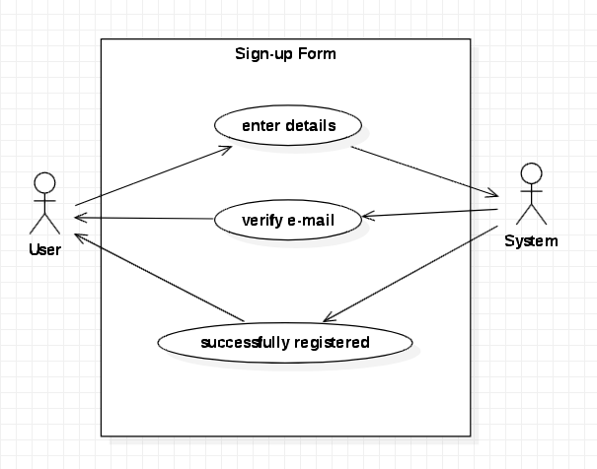

**Sign-up Form:**



**User Login:**

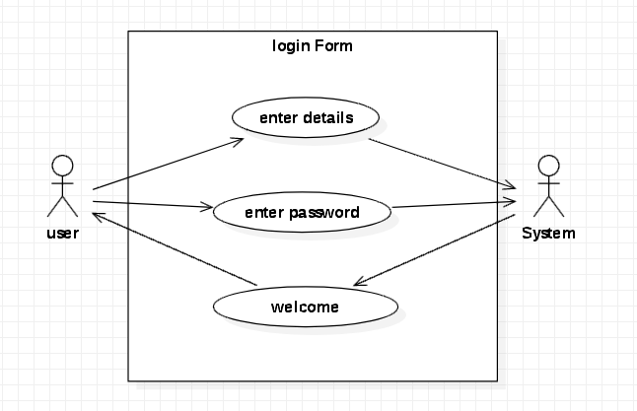

**Admin Login:**

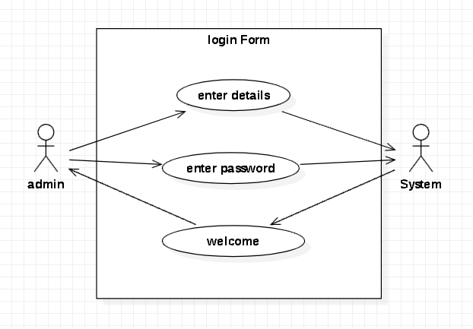

**Dealer Login :**

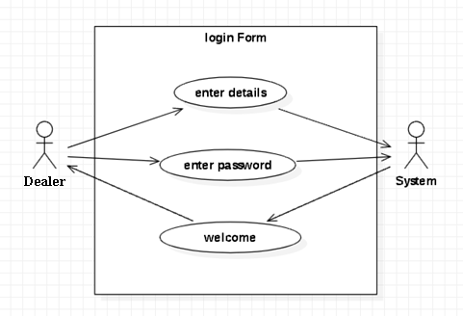

* **Data Flow Diagram:**

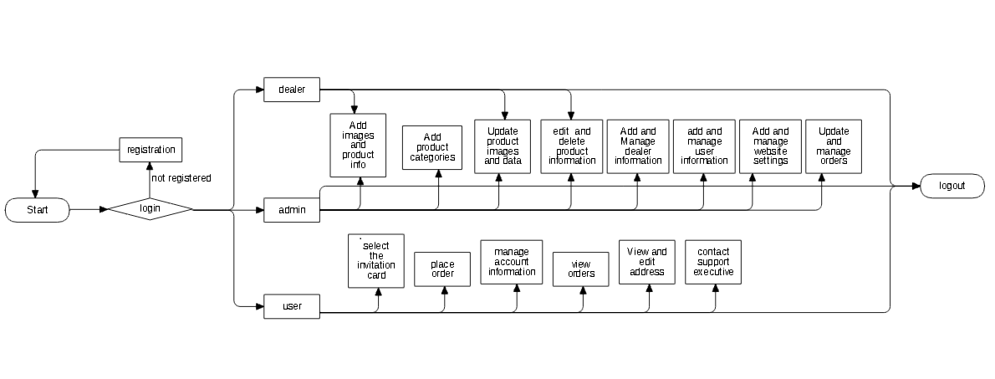

* **Class Diagram:**

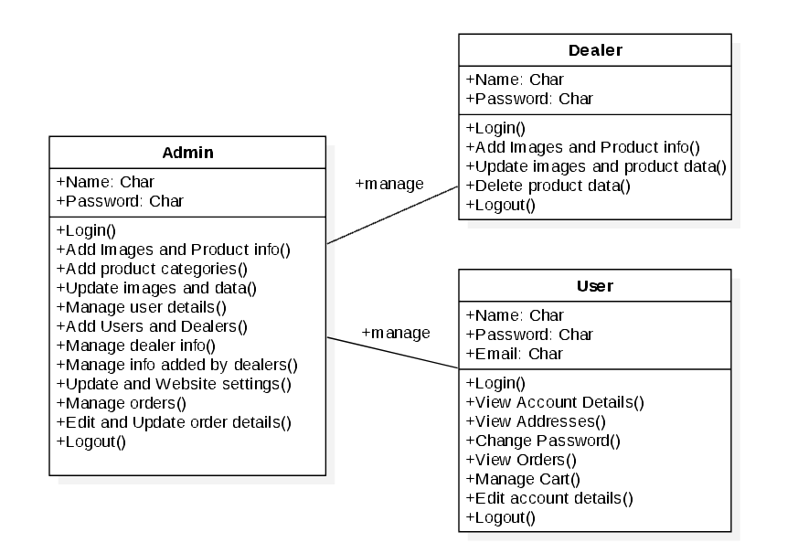

# CHAPTER 4: SYSTEM DESIGN

## 4.1 Basic Modules

1. **Contact Us**: It helps the user to get in contact with the admin and in case of any query or inconvenience.
2. **About us:** It helps the user to know more about the creator and their motive to create the website, and how the website would work.
3. **Login and Security Tab:** It helps the user to edit their account information.

## 4.2 Procedural Design

### 4.2.1 Logic Diagrams

**Login Activity:**



**Registration Activity Diagram:**



**Admin Activity Diagram:**



**User Activity Diagram:**



**User Activity Diagram:**

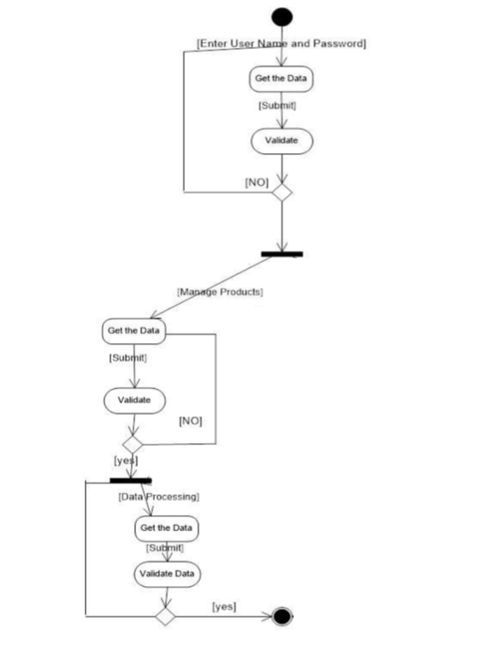

## 4.3 User Interface Design

**Client Side:**

**Homepage:**

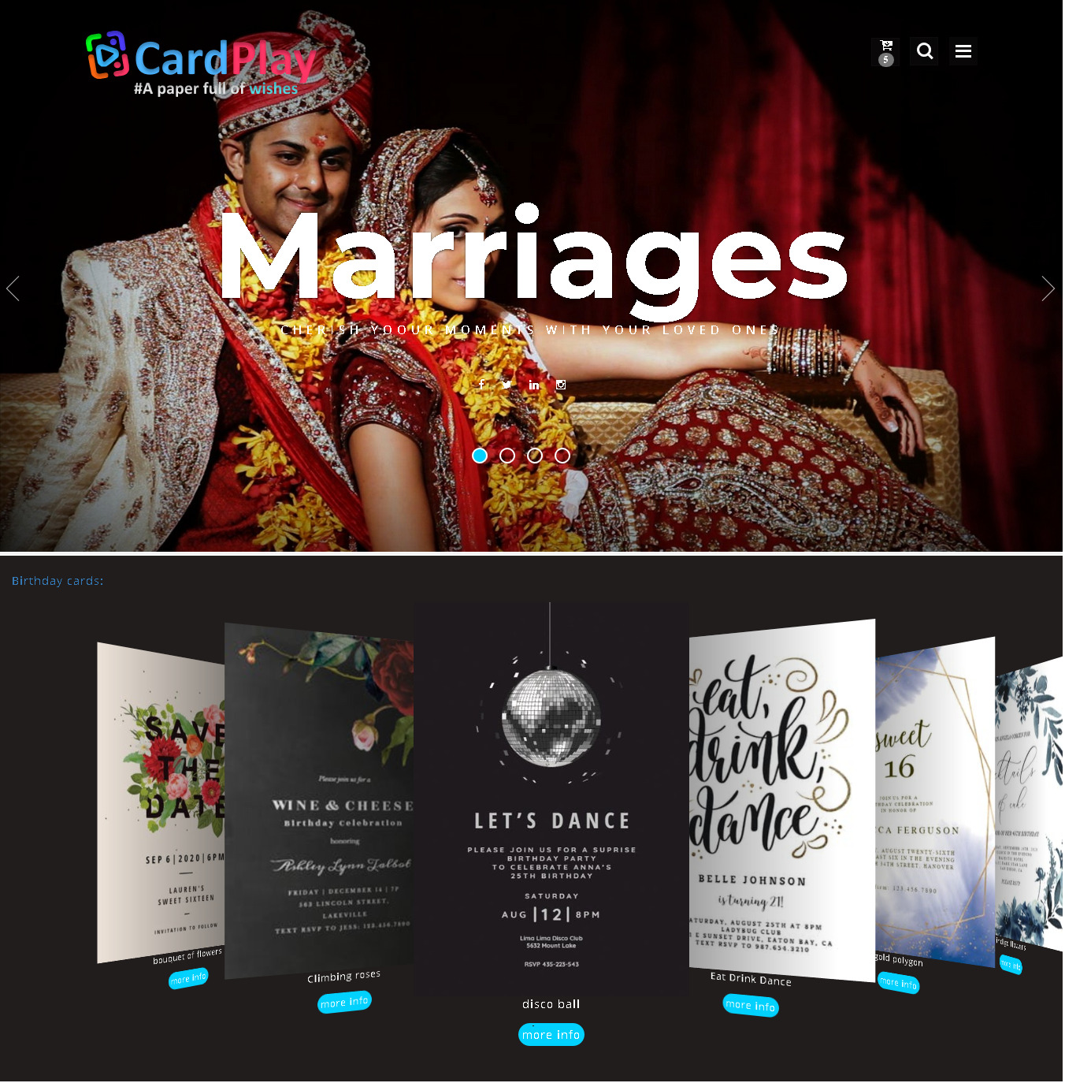

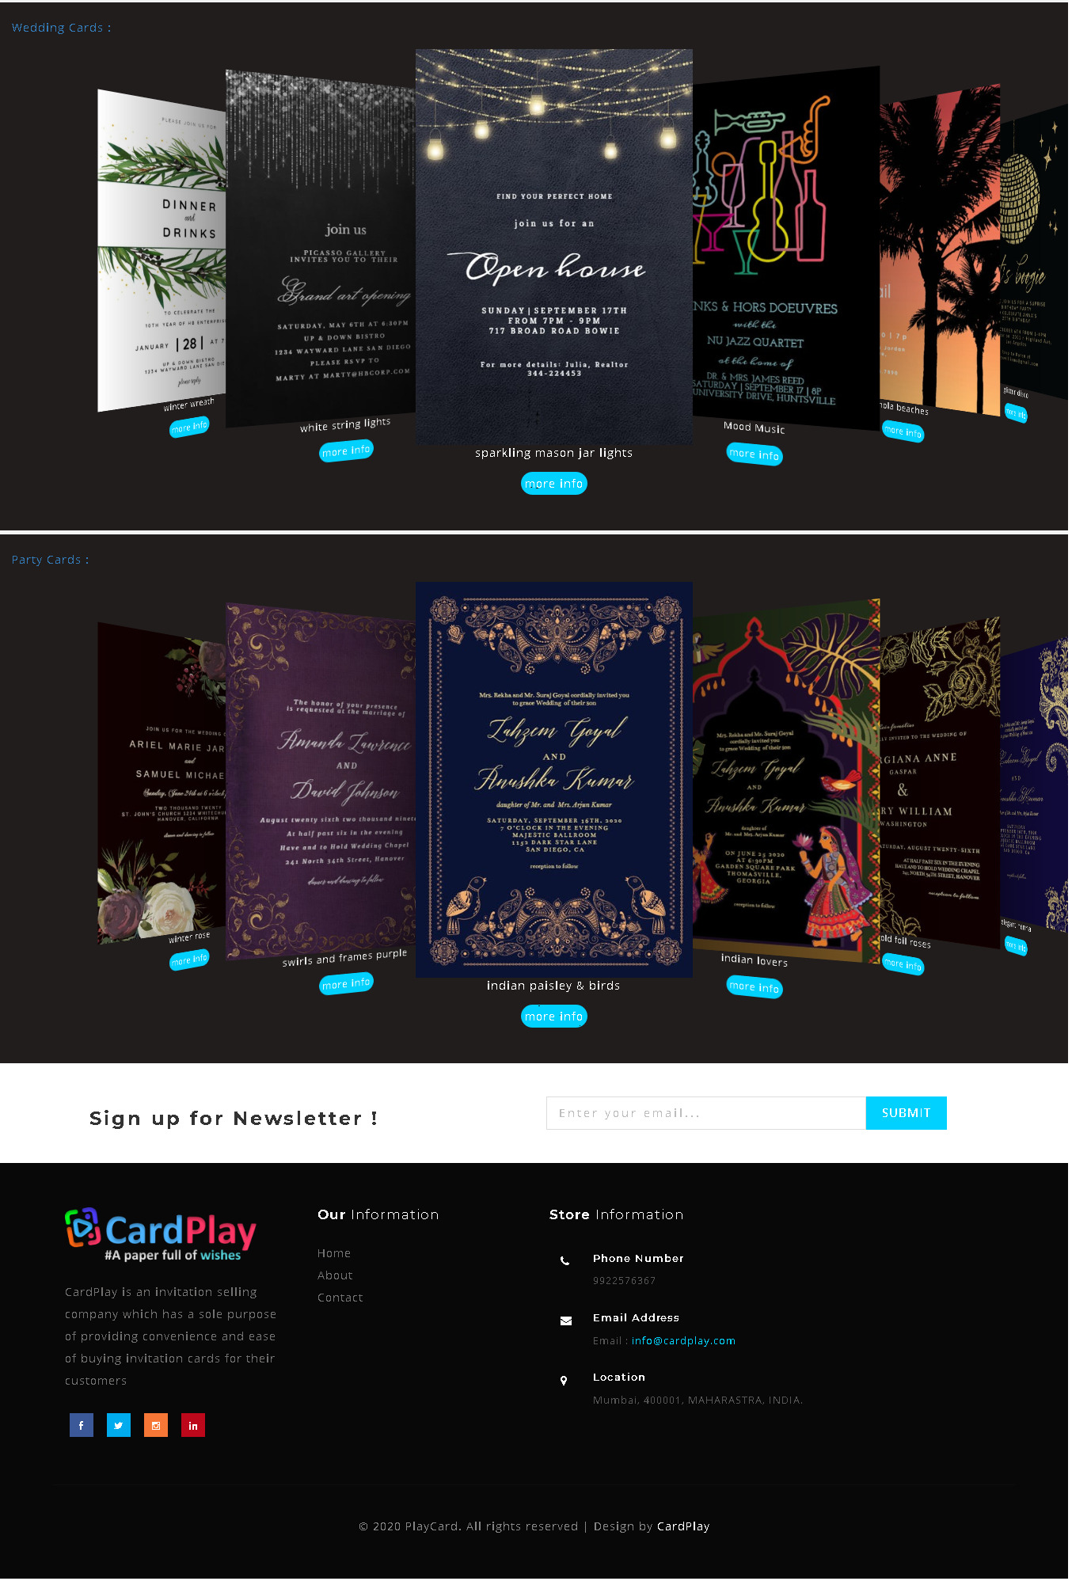

**Footer section:**

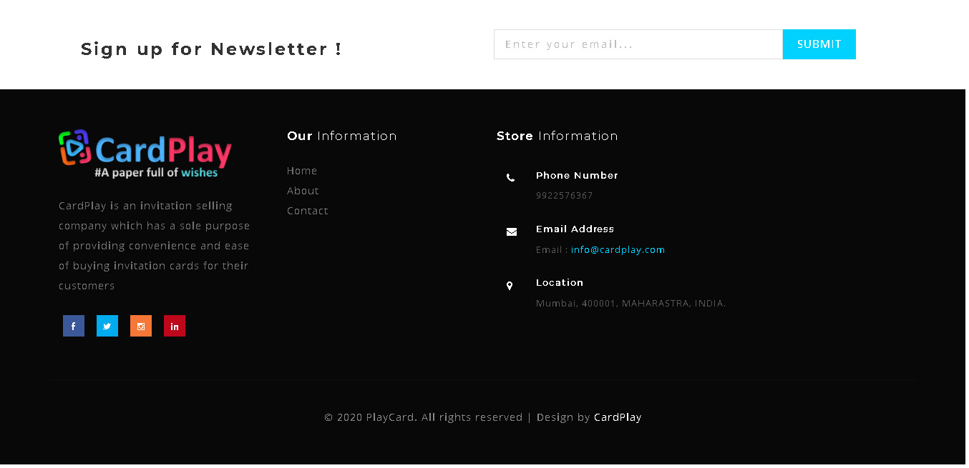

**About us:**

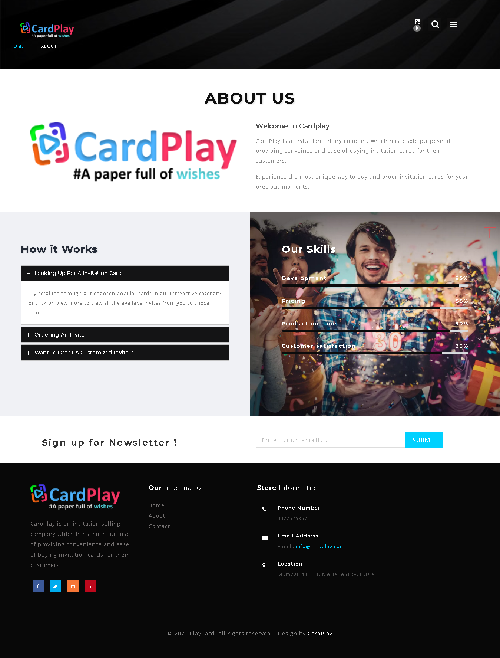

**Contact Us:**

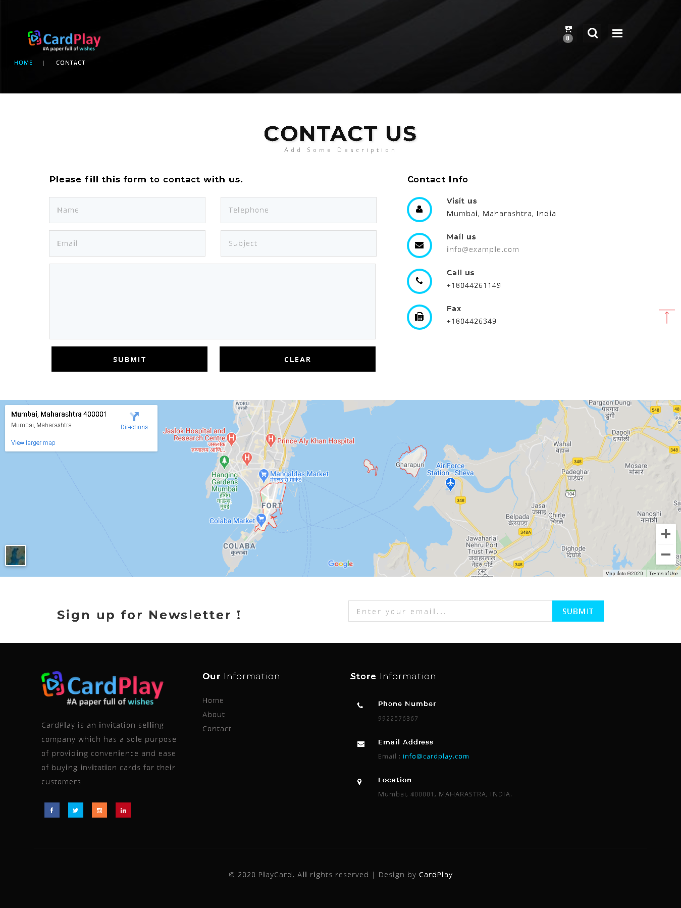

**Login Page:**

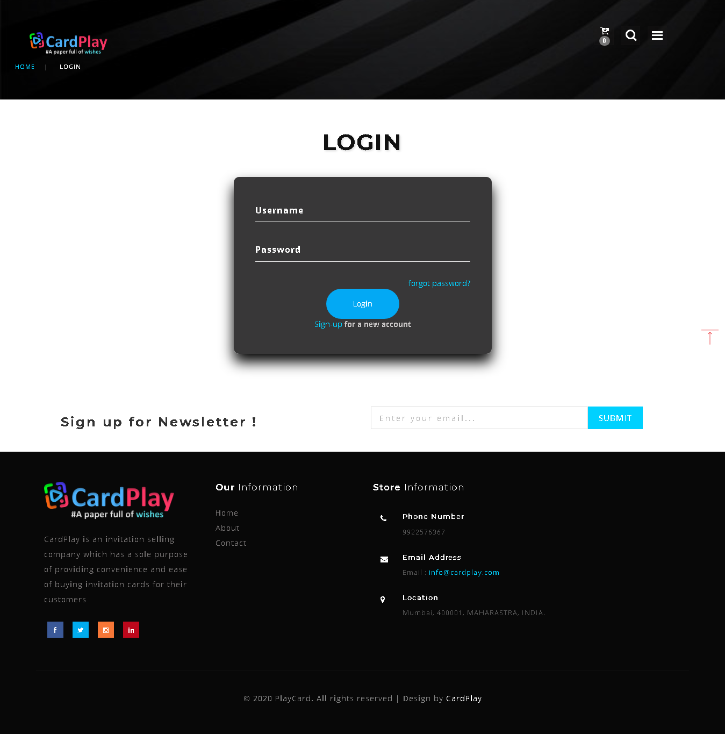

**Signup Page:**

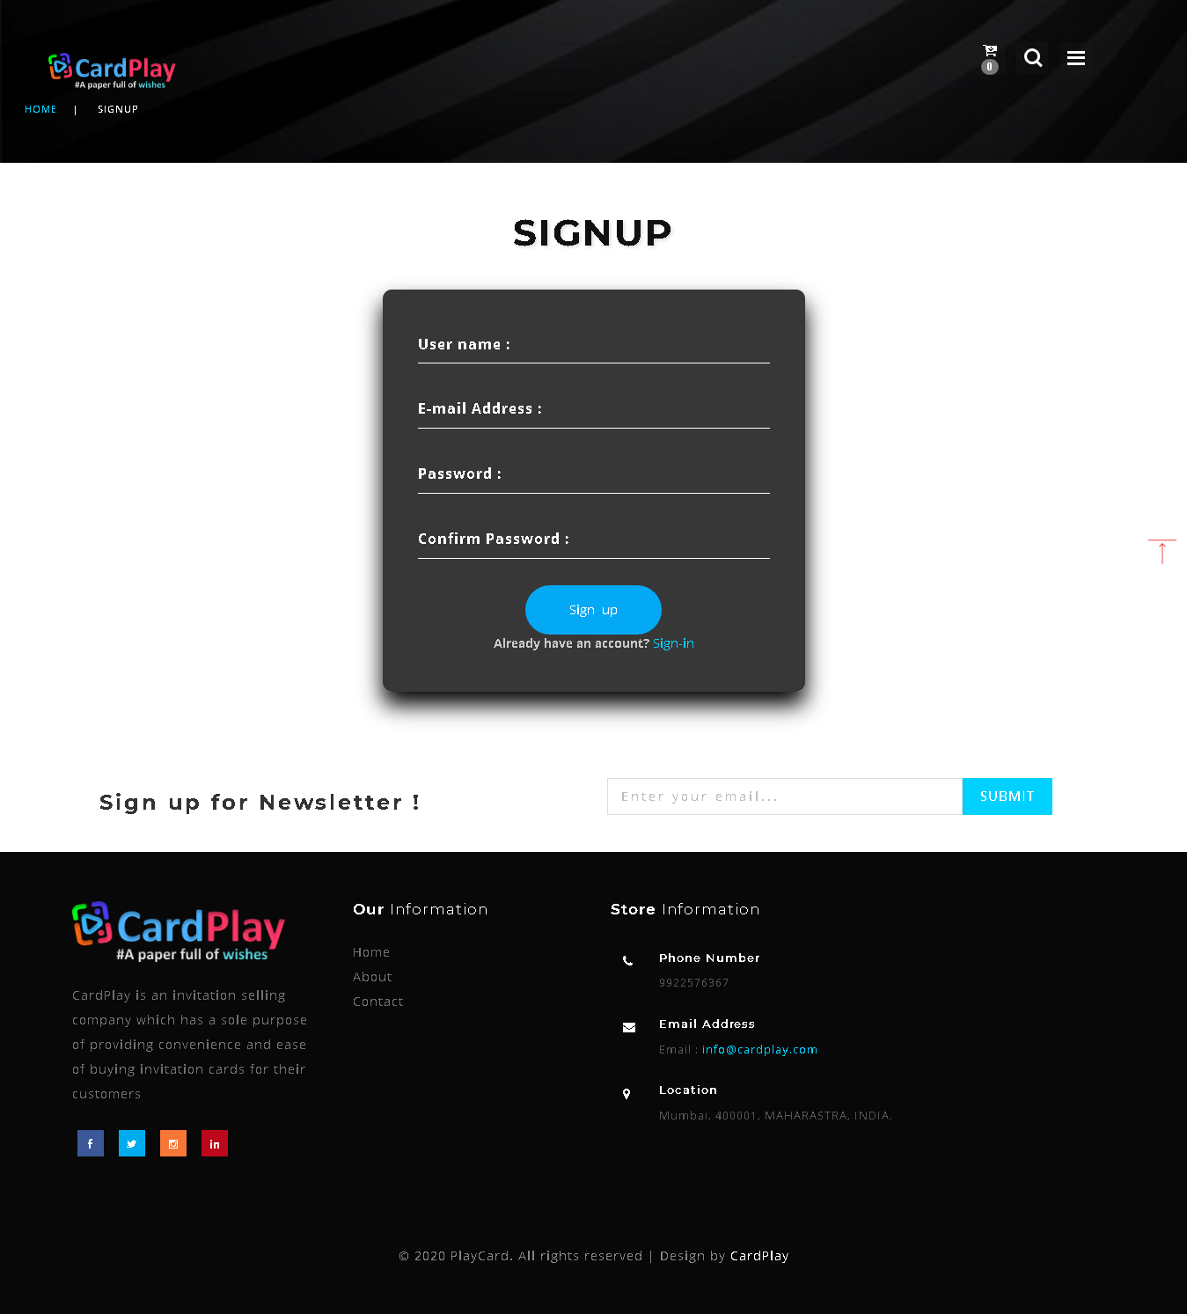

**Card Category Swiper:**



**Category (All cards):**

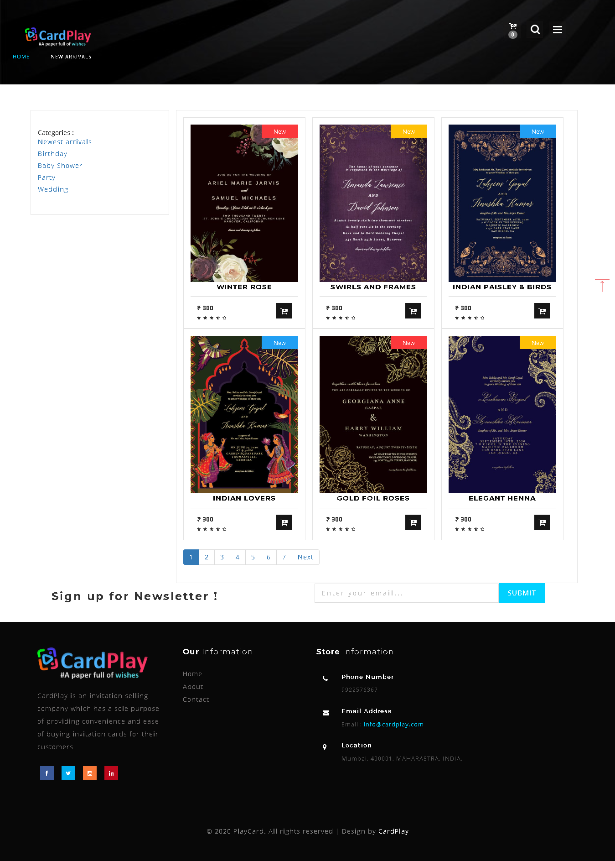

**Individual card:**

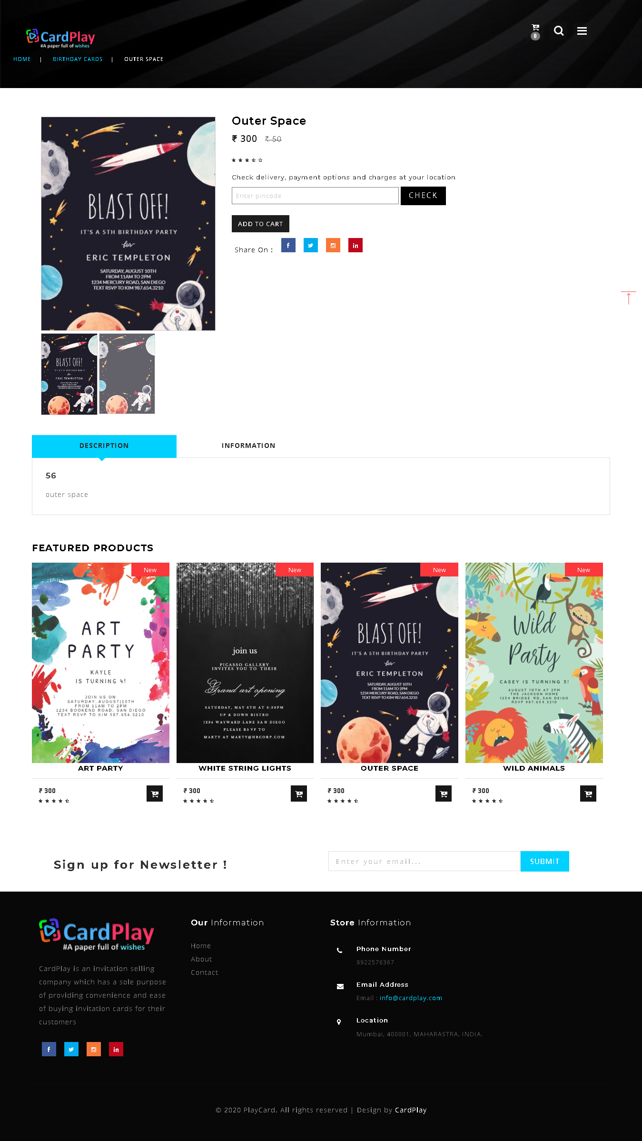

**Cart:**

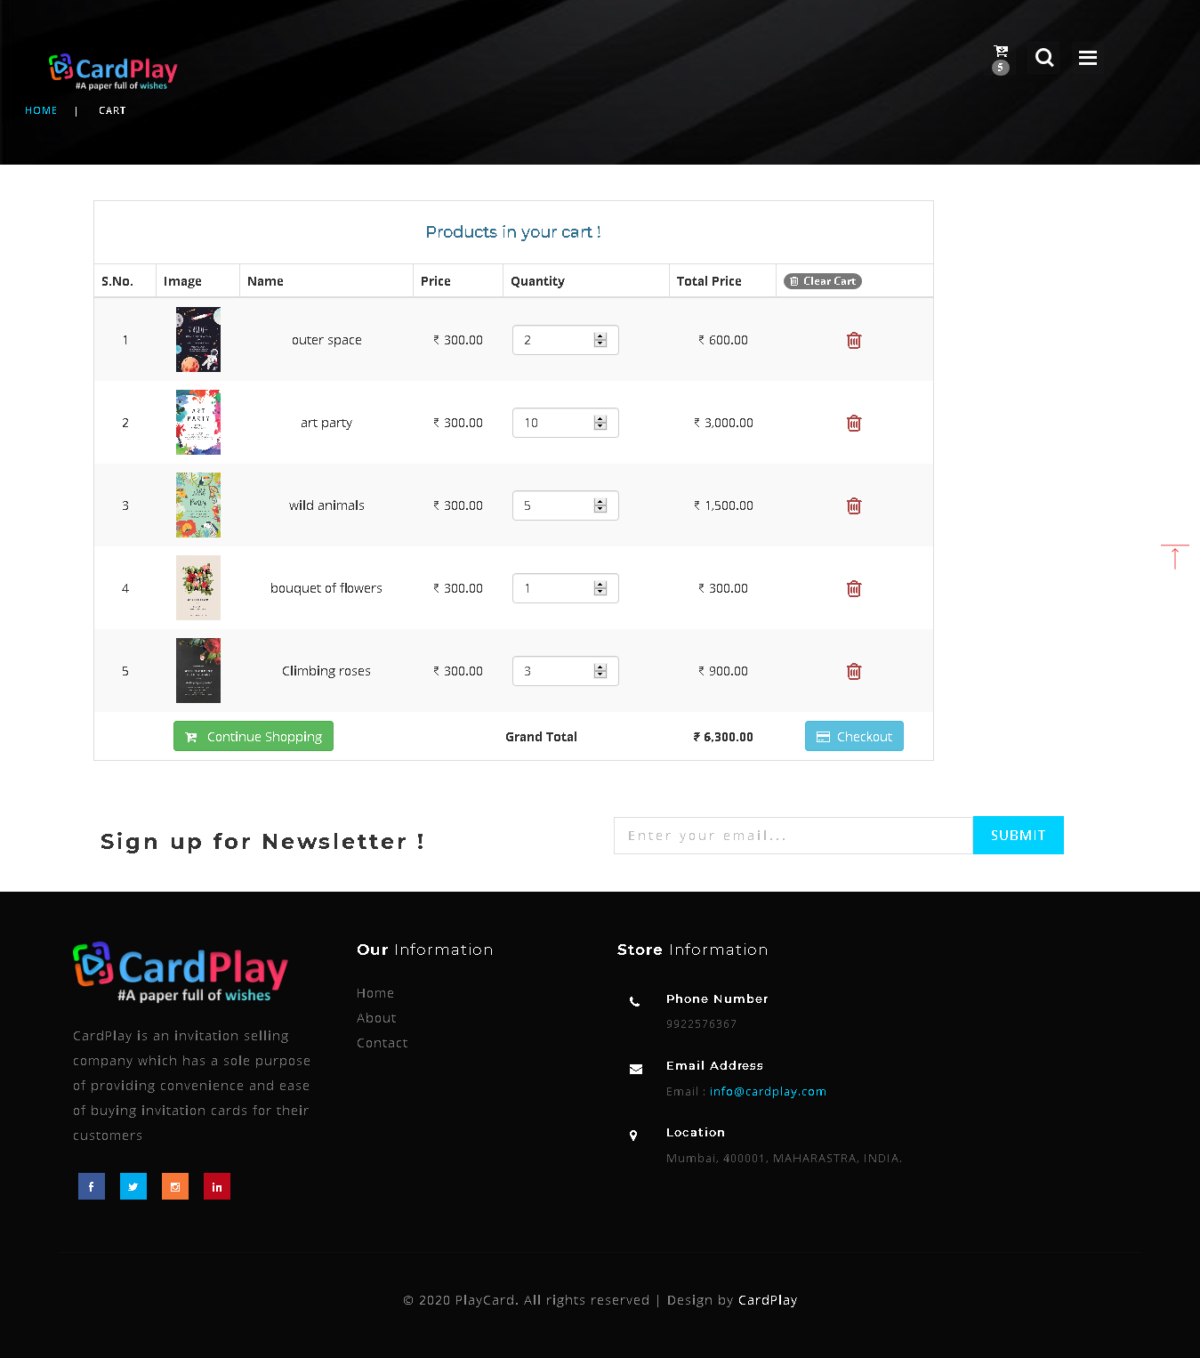

**Check Out:**

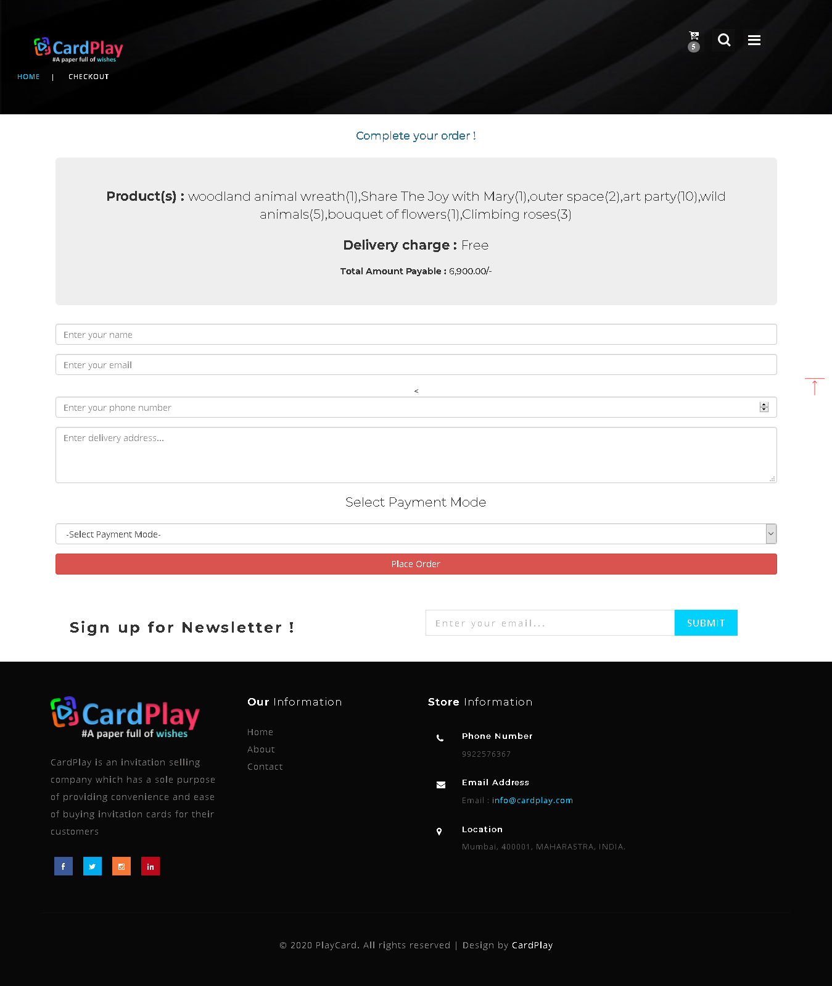

**Order Placement:**

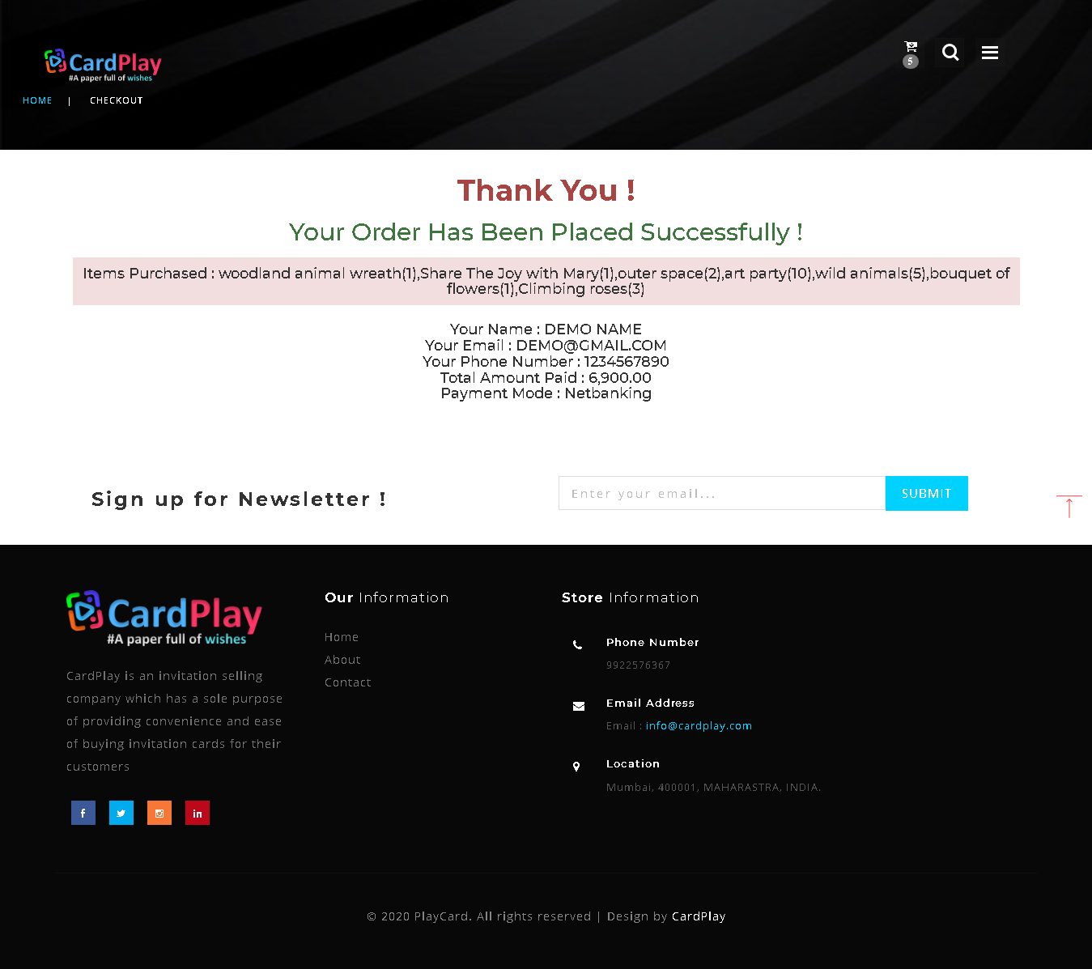

**Dashboard:**

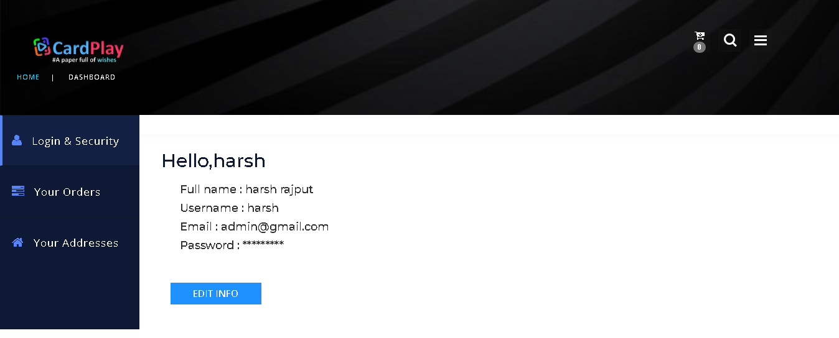

**User edit info:**

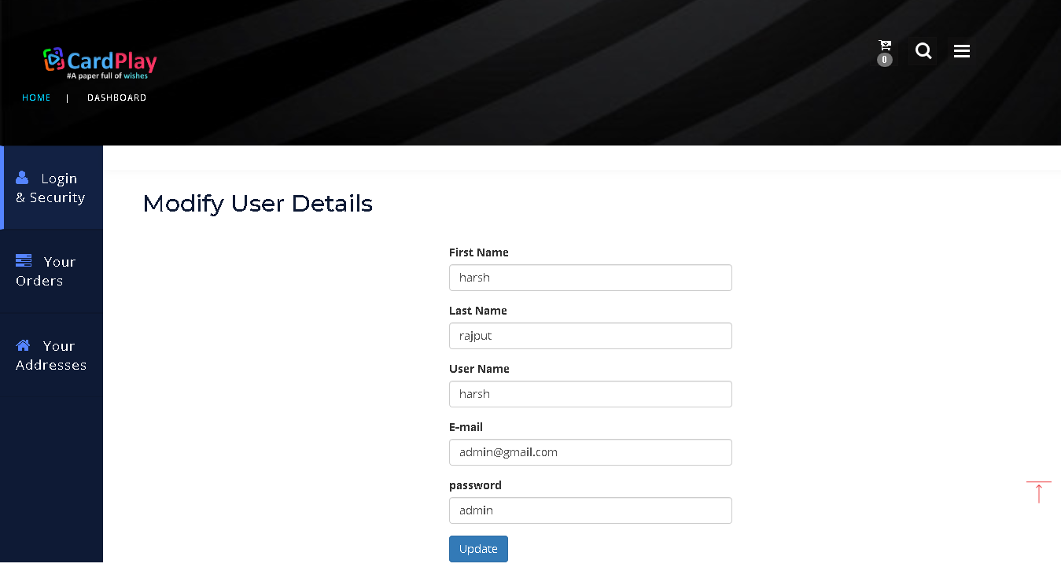

**Orders:**

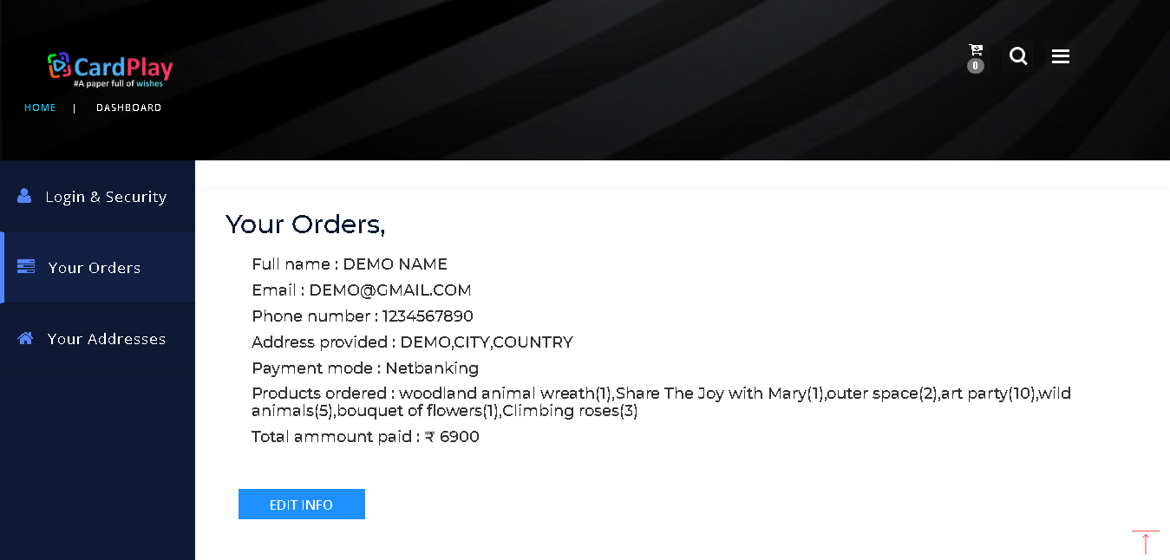

**Address:**

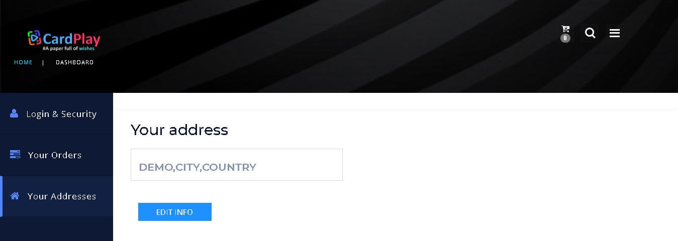

**Edit address:**

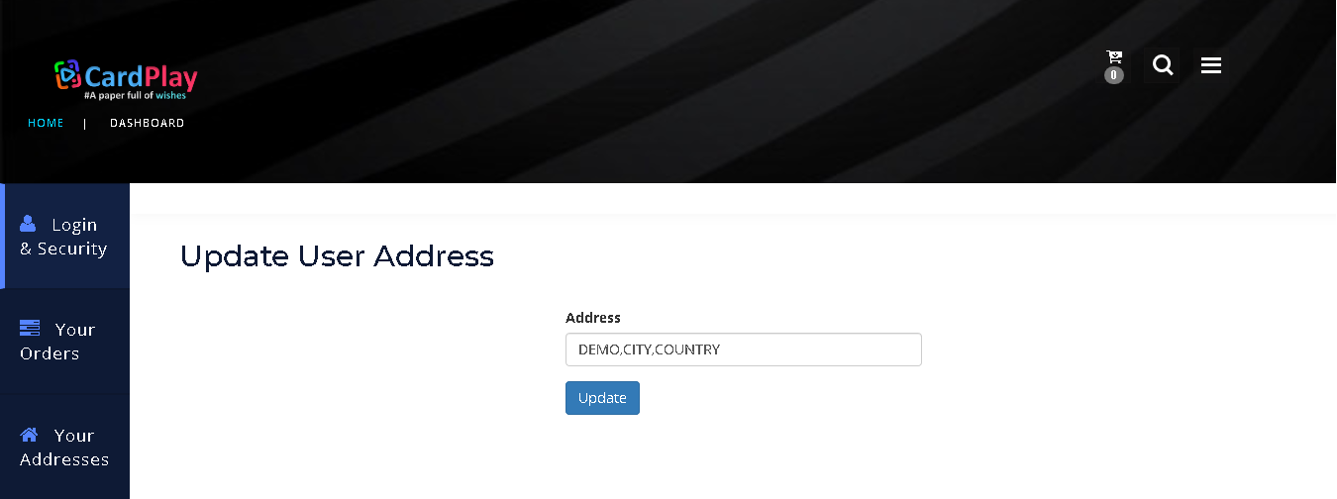

**Dealer Side:**

**Login:**

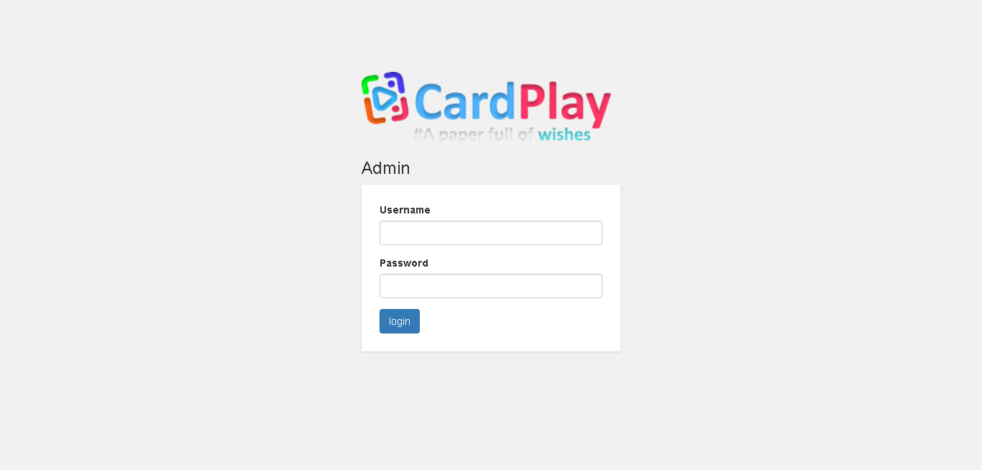

**Uploaded cards by Dealer:**

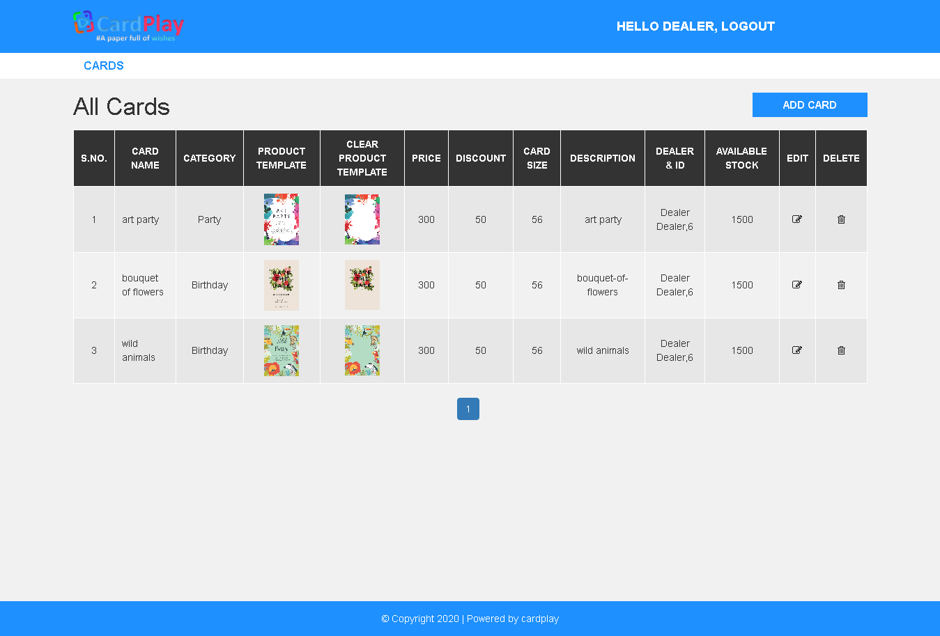

**Add cards:**

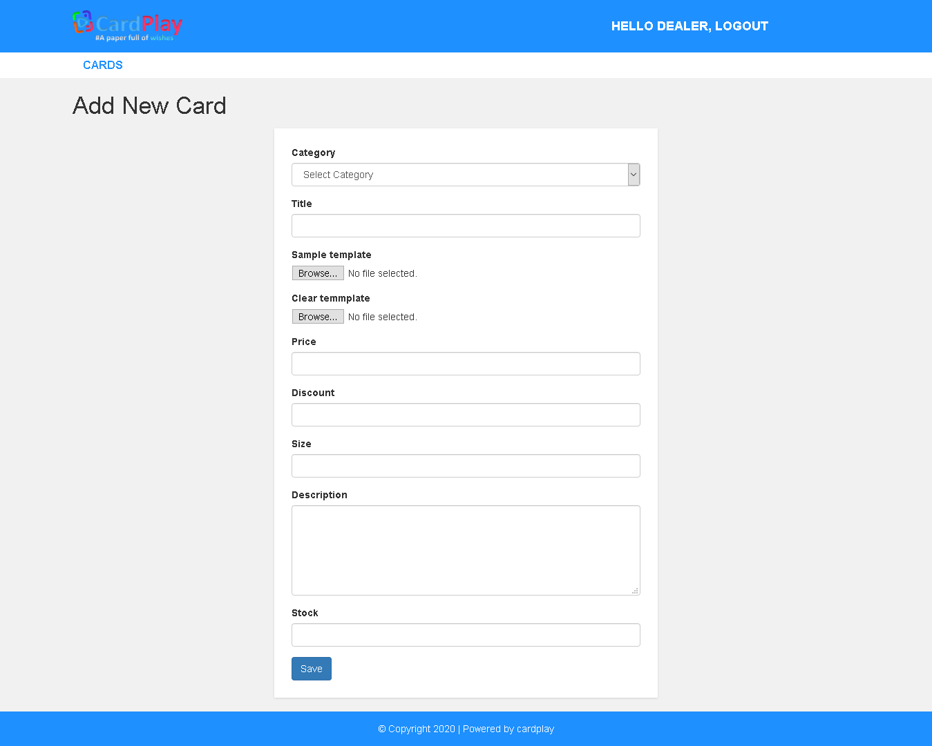

**Update cards added by dealer:**

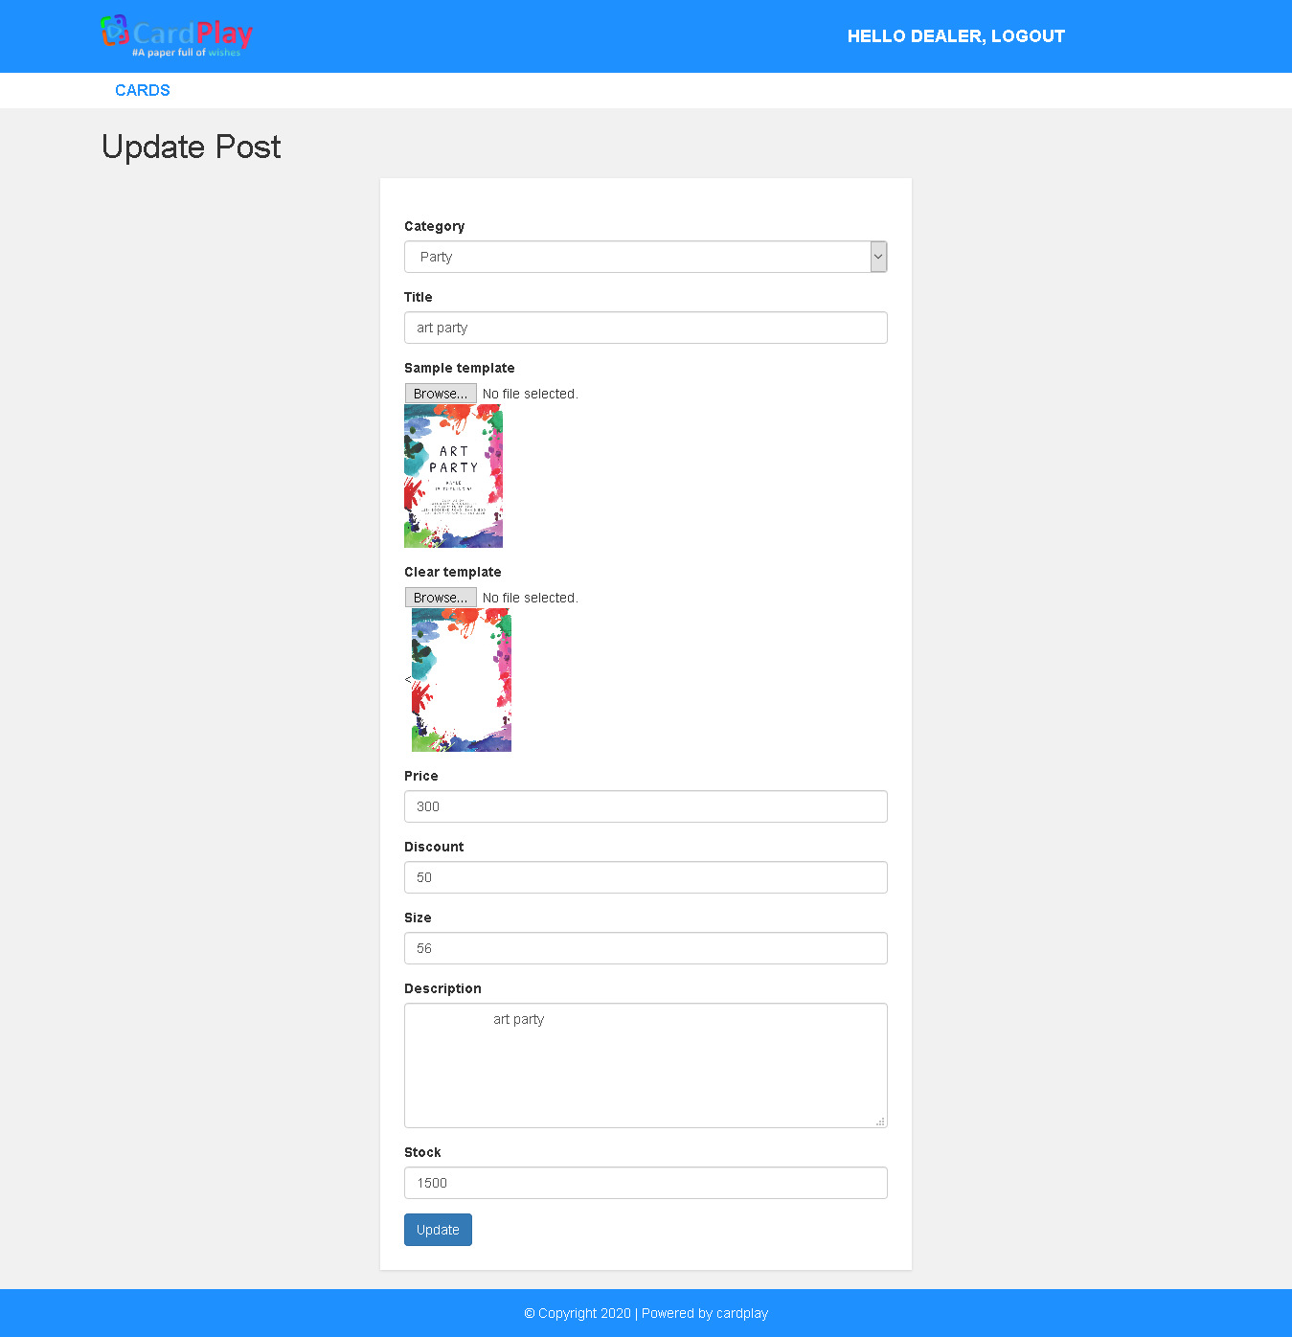

**Admin Side:**

**Login:**



**Admin Dashboard:**

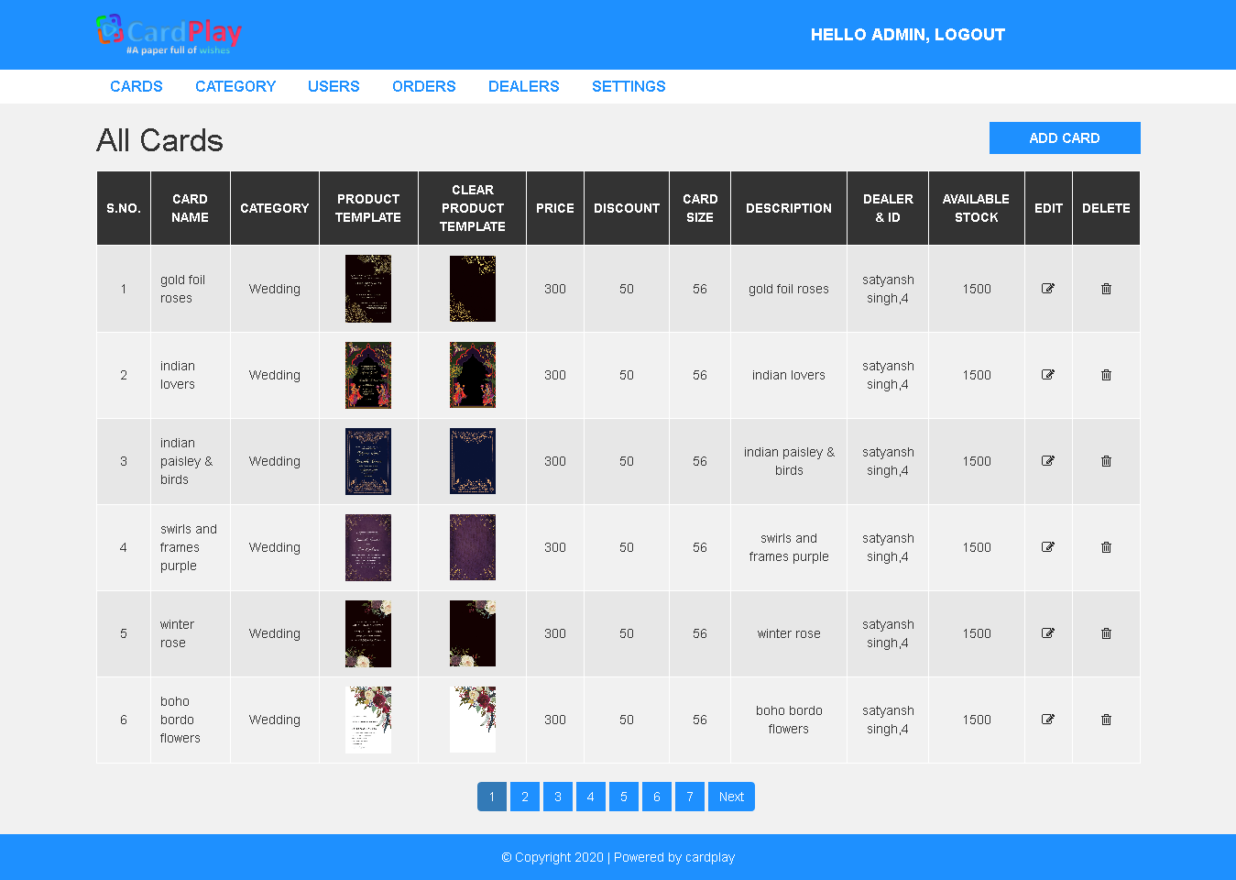

**Admin category section:**

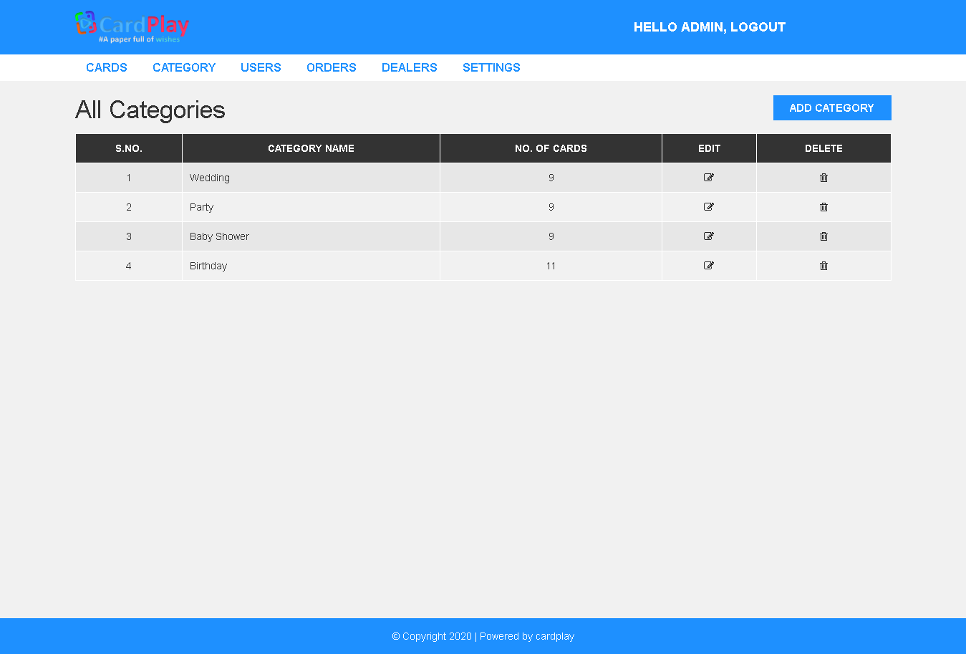

**Add categories:**

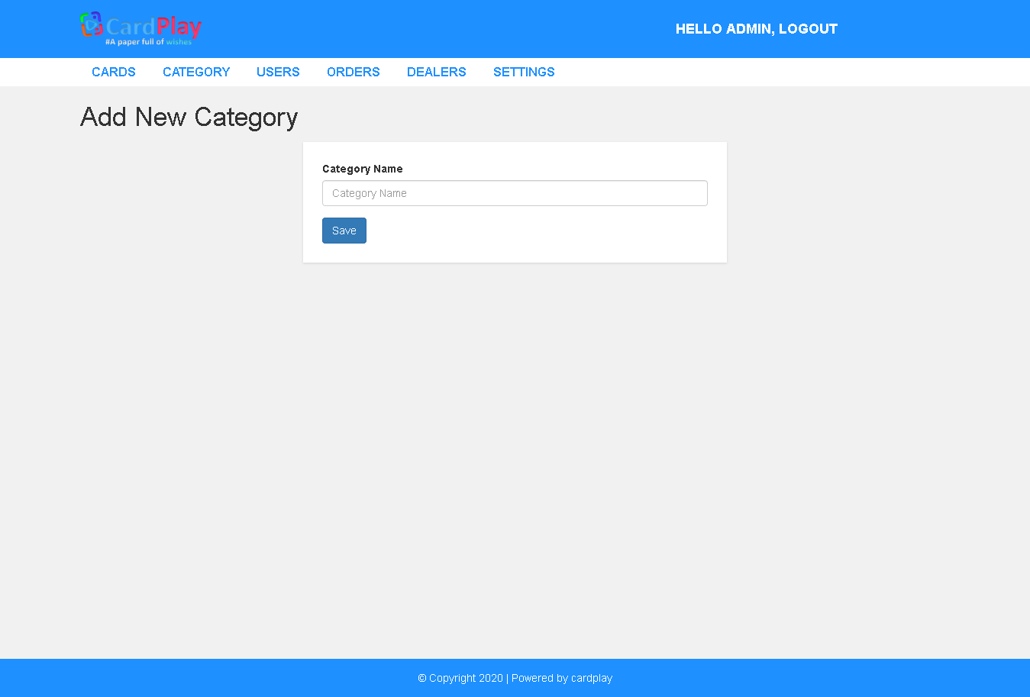

**Edit categories:**

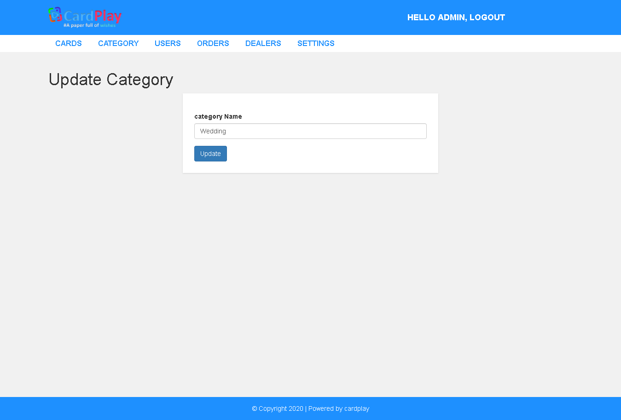

**Users Section:**

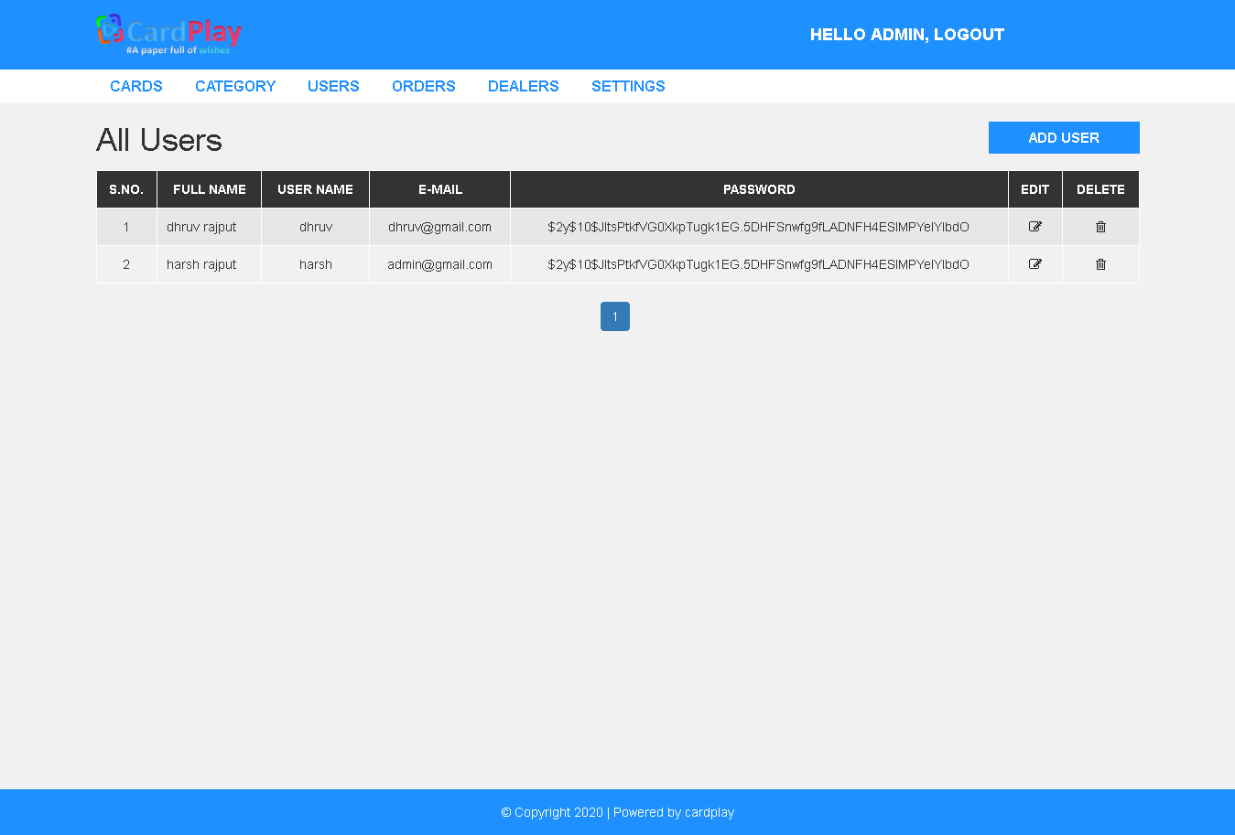

**Add users:**

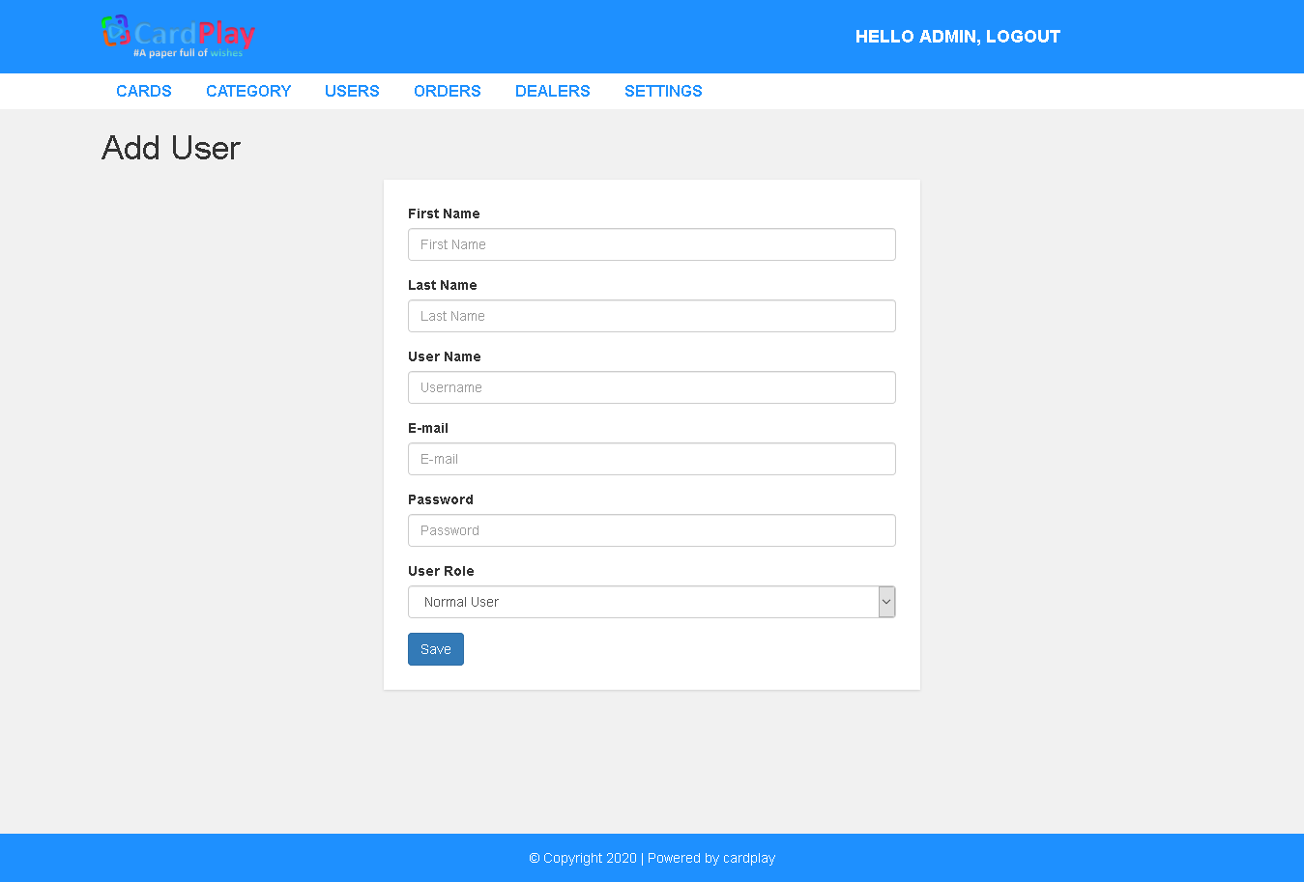

**Edit users:**

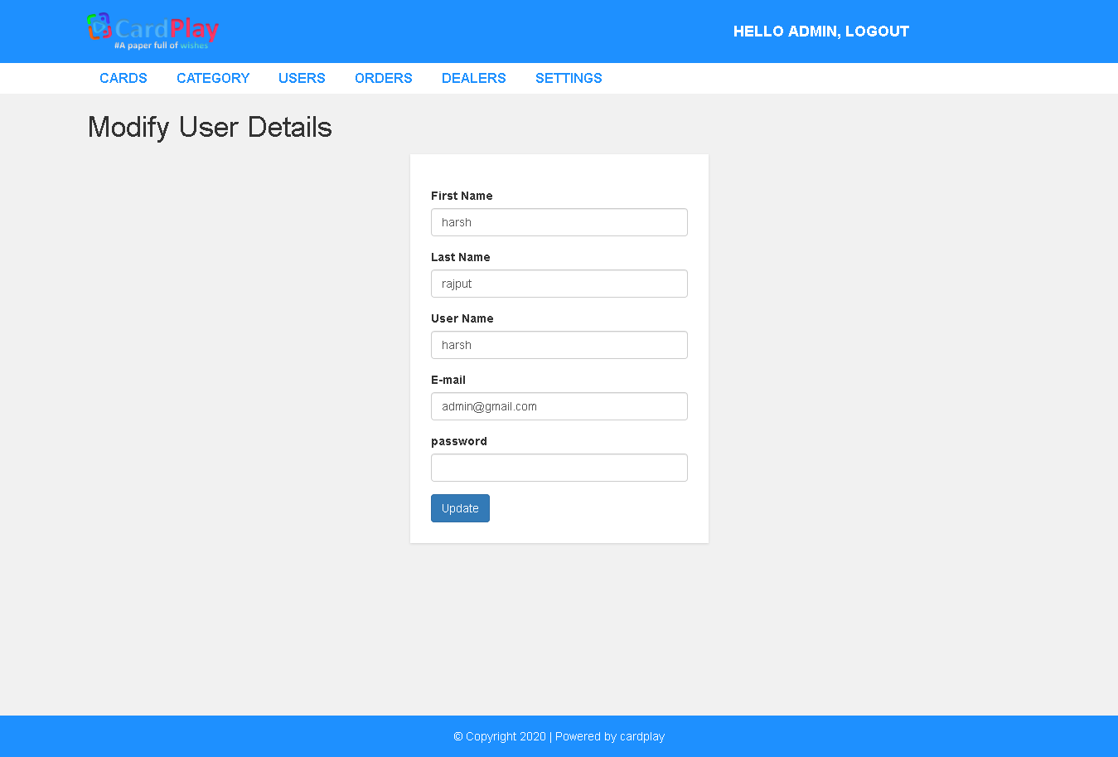

**Admin orders section:**

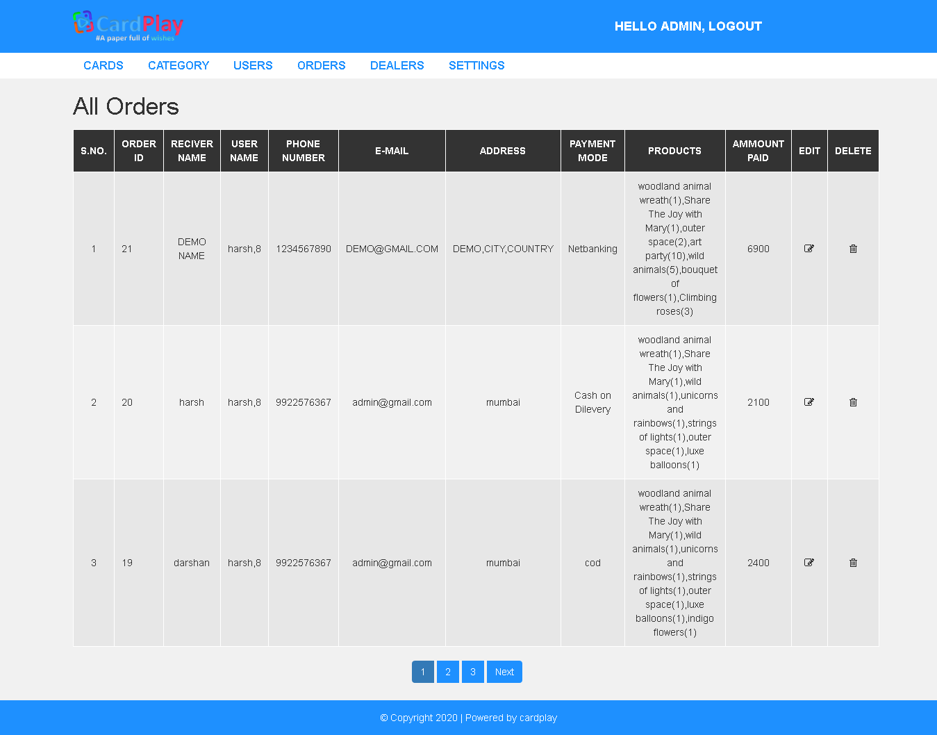

**Edit orders:**

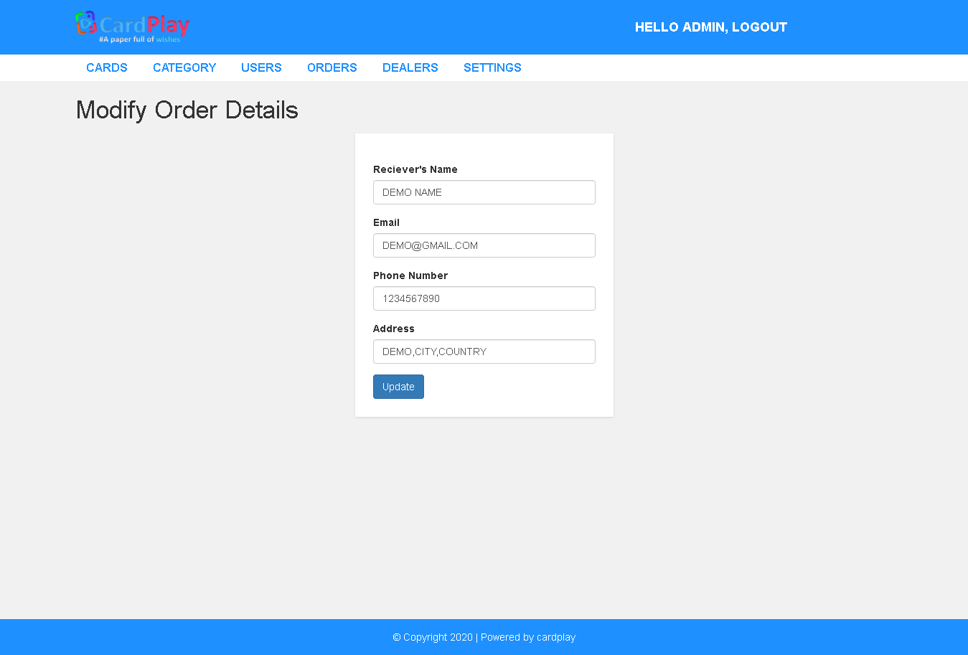

**Admin dealers section:**

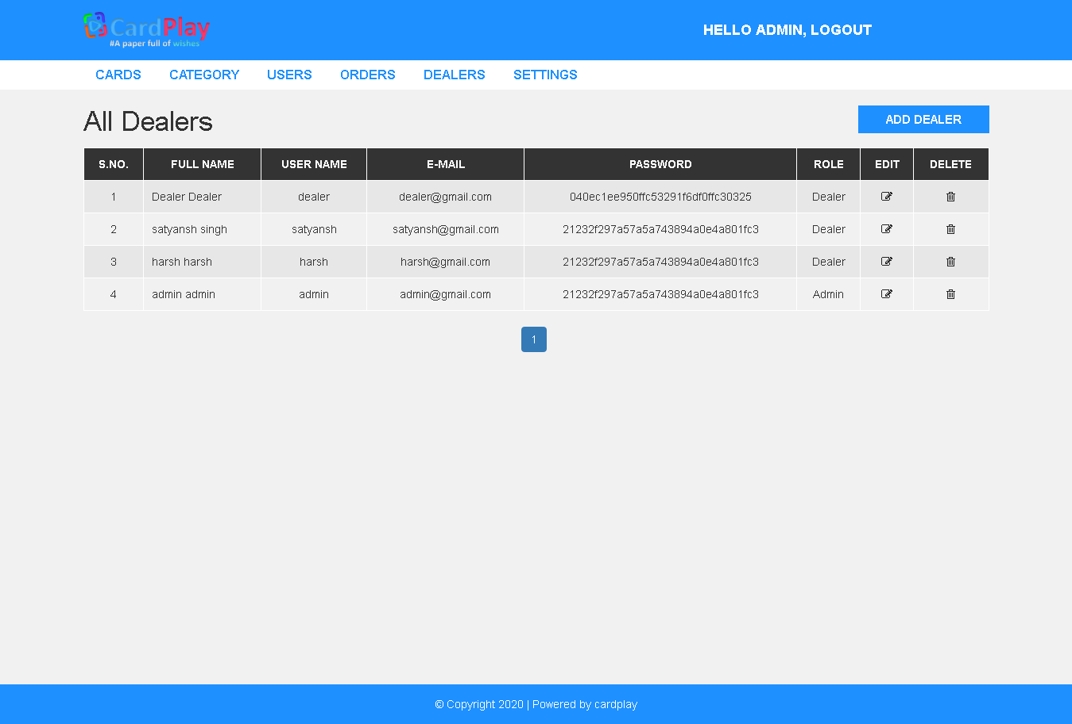

**Add dealers:**

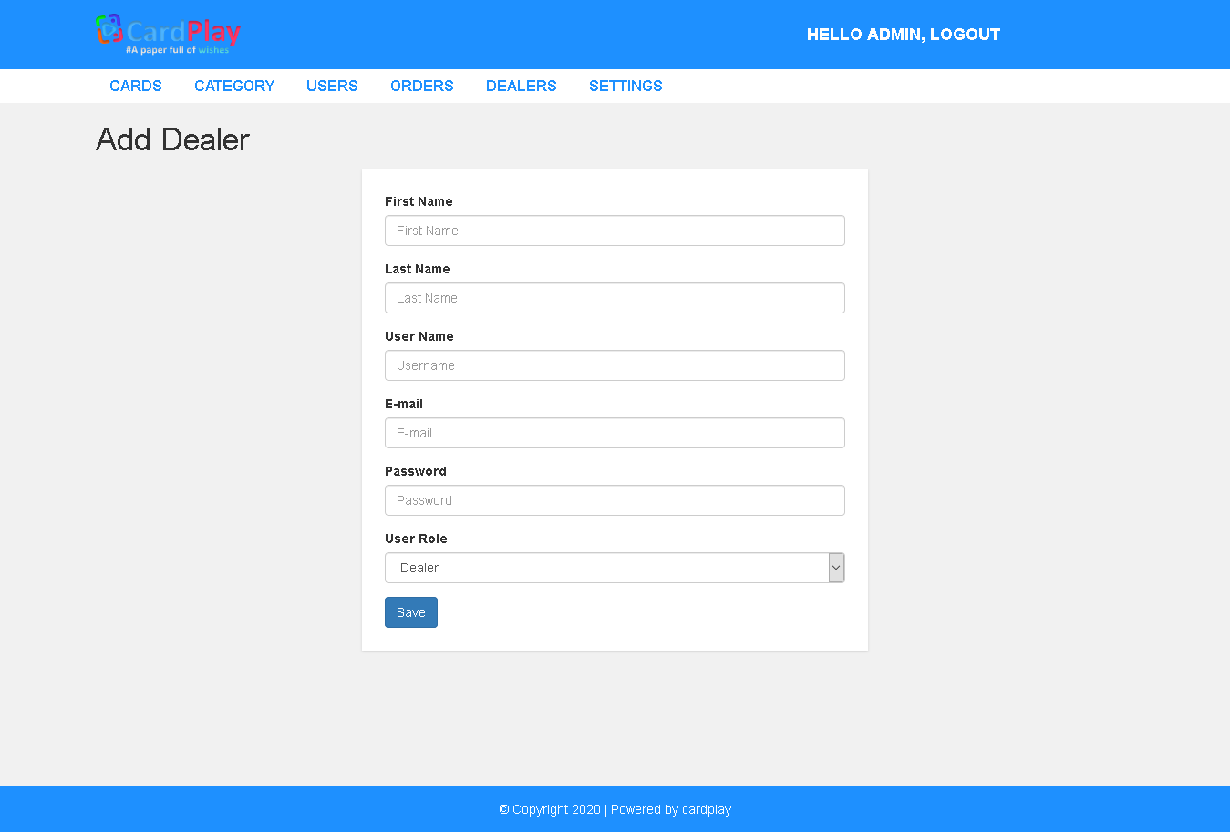

**Edit dealers:**

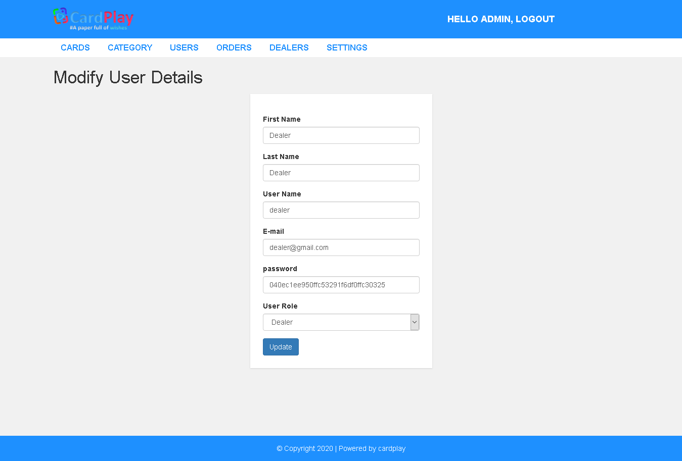

**Website settings panel:**

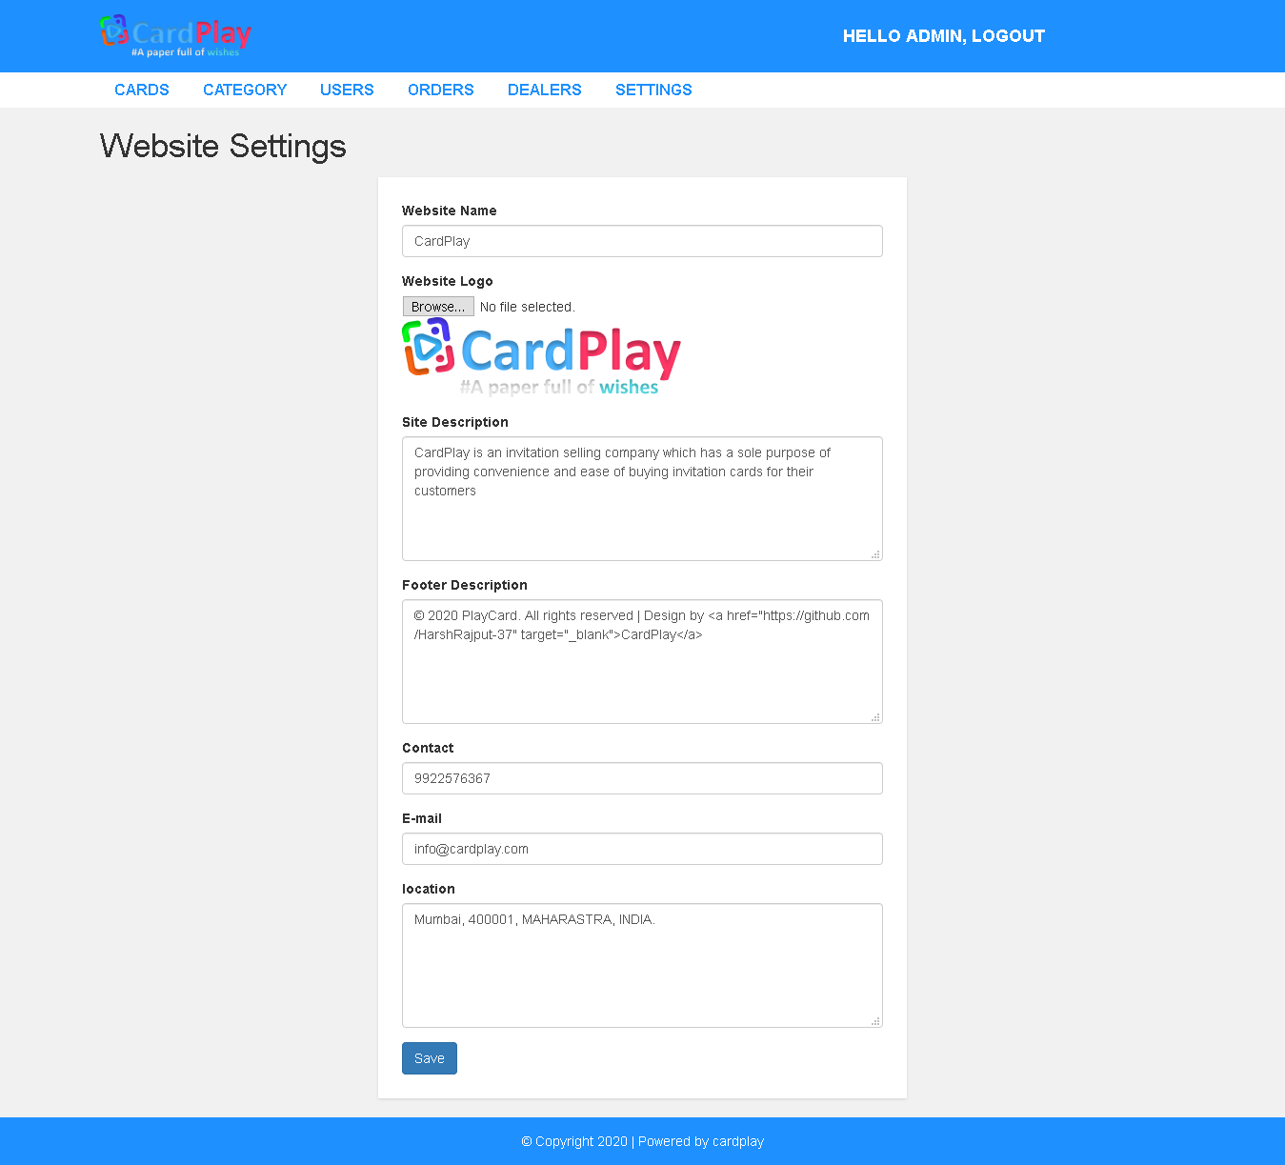

## 4.4 Security Issues

1. **Malicious External and Internal Cyber security Attacks:**

External cyber security attacks surface in a variety of ways. User clicking a malicious hyperlink containing a virus can provide a cybercriminal access to unprotected connections to the Internet. A user opening an attachment sent by a hacker provides them direct access to the user’s terminal. It is important for website admin to understand and consider the potential risk of being attacked by an external entity. One-way admins can protect themselves from the external threat is by performing a risk analysis and conducting periodic vulnerability testing.

1. **Value of Information**

If an attacker gains access to an internal system, financial information may be exposed. Most organizations hold extremely profitable data about their employees’ personally identifiable information (PII). This type of information contains addresses, dates of birth, social security numbers, and any other information a criminal would use to steal an identity. An attacker can obtain PII of a user without an associated credit card, leaving a user largely unprepared to respond or even be aware that their identity has been stolen. This information is used by the attacker, sold to another criminal, or even be ransomed back at a high cost.

## 4.5 Test Cases Design

1. **White box testing:**

* It is also called as STRUCTURAL TESTING or GLASS BOX TESTING.
* Testers use the knowledge of internal logic of the system.
* Mostly verification techniques are used.
* It does not ensure that the user requirement had been met.
* The test may not mimic the real-world situations.
* Cost is very high since expert testers are required.

1. **Black box testing:**

* It is also called as FUNCTIONAL TESTING.
* These tests are conducted at interface.
* Testers do not have information about the _ internal functionality of the system.
* Mostly validation techniques are used.
* It stimulates the actual system usage.
* They have potential of not detecting the logical errors.

1. **Unit testing:**

* In unit testing the individual component are tested independently to ensure their quality.
* The focus is to uncover the errors in design and implementation.

1. **System testing:**

* The system test is a series of tests conducted to fully test the computer- based system.

**The main focus of such tests is to test:**

* + System functions and performance.
  + System reliability and recoverability (recovery test).
  + System installation (installation test).
  + System behavior in special condition (stress test).
  + System user operations (acceptance test).
  + Hardware and software integration and collaboration.
  + Integration of external software and the system.

# CHAPTER 5: IMPLEMENTATION AND TESTING

## 5.1 Implementation and Approaches

It has been made sure that the data base is secure from any malicious attacks coming from the client side while signing up onto the website. The given code has been used to remove any spaces between the entered texts into the text area that maybe some malicious code to cause harm to the database or it may be an unharmfull script.

<?php

if (isset($_POST['signup-submit'])) {

require 'dbh.php';

$username = $_POST['uid'];

$email = $_POST['email'];

$password = $_POST['pwd'];

$passwordRepeat = $_POST['pwd-repeat'];

if (empty($username) || empty($email) || empty($password) || empty($passwordRepeat) ) {

header("Location: ../signup.php?error=emptyfields&uid=".$username."&email=".$email);

exit();

}

else if (!filter_var($email, FILTER_VALIDATE_EMAIL) && !preg_match("/^[a-zA-Z0-9]*$/", $username)) {

header("Location: ../signup.php?error=invalidemailuid");

exit();

}

else if (!filter_var($email, FILTER_VALIDATE_EMAIL)) {

header("Location: ../signup.php?error=invalidemail&uid=".$username);

exit();

}

else if (!preg_match("/^[a-zA-Z0-9]*$/", $username)) {

header("Location: ../signup.php?error=invaliduid&email=".$email);

exit();

}

else if ($password !== $passwordRepeat) {

header("Location:../signup.php?error=passwordcheck&uid=".$username."&email=".$email);

exit();

}

else {

$sql = "SELECT uidUsers FROM user WHERE uidUsers=?";

$stmt = mysqli_stmt_init($conn);

if (!mysqli_stmt_prepare($stmt, $sql)) {

header("Location: ../signup.php?error=sqlerror");

exit();

}

else {

mysqli_stmt_bind_param($stmt, "s", $username);

mysqli_stmt_execute($stmt);

mysqli_stmt_store_result($stmt);

$resultCheck = mysqli_stmt_num_rows($stmt);

if ($resultCheck > 0) {

header("Location: ../signup.php?error=usertaken&email=".$email);

exit();

}

else { $sql = "INSERT INTO user (uidUsers, emailUsers, pwdUsers) VALUES (?, ?, ?)";

$stmt = mysqli_stmt_init($conn);

if (!mysqli_stmt_prepare($stmt, $sql)) {

header("Location: ../signup.php?error=sqlerror");

exit();

}

else {

$hashedPwd = password_hash($password, PASSWORD_DEFAULT);

mysqli_stmt_bind_param($stmt, "sss", $username, $email, $hashedPwd);

mysqli_stmt_execute($stmt);

header("Location: ../signup.php?signup=success");

exit();

}

}

}

mysql_stmt_close($stmt);

mysql_close($conn);

}

}

else {

header("Location: ../signup.php");

exit();

}

This makes sure that no scripts can be written into the textbox while signing up onto the website.

## 5.2 Coding Details and Code Efficiency

<hr>

<div class="swiper-container">

<nav aria-label="breadcrumb">

<ol class="breadcrumb">

<li class="breadcrumb-item active" aria-current="page"><a href="category.php?cid=2">Baby Shower cards:</a></li>

</ol>

</nav>

<div class="swiper-wrapper">

<?php

include "includes/dbh.php";

$sql = "SELECT products.category, products.product_id, products.product_name, products.product_template, product_categories.category_id FROM products LEFT JOIN product_categories ON products.category = product_categories.category_id WHERE products.category= 2 ORDER BY products.product_id DESC LIMIT 6";

$result = mysqli_query($conn, $sql) or die("Query Failed products");

if(mysqli_num_rows($result) > 0){

while($row = mysqli_fetch_assoc($result)) {

?>

<div class="swiper-slide">

<div class="Slide">

<img src="admin/product_images/sample/<?php echo $row['product_template'];?>">

<div class="details">

<p><?php echo $row['product_name'];?></p><br>

<p><a href='single.php?id=<?php echo $row['product_id'];?>&&cid=<?php echo $row['category_id'];?>'> more info</a></p>

</div>

</div>

</div>

<?php

}

}

?>

<div class="swiper-slide">

<div class="Slide">

<a href="category.php?cid=2"><img src="images/view-more.png"></a>

</div>

</div>

</div>

</div>

<script src="js/swiper.min.js"></script>

<script>

var swiper = new Swiper('.swiper-container',

{

effect: 'coverflow',

grabCursor: true,

centeredSlides: true,

slidesPerView: 'auto',

coverflowEffect: {

rotate: 30,

stretch: 0,

depth: 200,

modifier: 1,

slideShadows : true,

},

pagination: {

el: '.swiper-pagination',

},

});

</script>

**This is the sole code for the swiper class used for showing cards**

### 5.2.1 Code Efficiency

The code is optimized in such a way that the webpage takes less time to load completely.it take a few seconds to completely load as the website is mobile compatible too and has a lot more code in the background that takes a few extra seconds to get compiled by the browser.

## 5.3 Testing Approach

### 5.3.1 Unit Testing

Each unit of the website functionality has been checked so that it performs up to the users mark and as it is supposed to work. We have used the “TOP to BOTTOM” approach so as to make sure that every unit gets checked without leaving anything behind.

### 5.3.2 Integrated Testing

The whole website has been checked all together by hybrid top to bottom approach.it makes sure that no errors are left that may create problem in near future.

### 5.3.3 Beta Testing

The website has not been hosted for any beta testing phase so users cannot test the website for now. But the tests done by users in future are estimated to be same as the tests that are done by the admin.

## 5.4 Modifications and Improvements

The user interface have been improved so as to make the website more appealing and more practical in use.

The website is mobile platform friendly and can be accessed over mobile browser which would make it easier for the user to view the website.

Broken links have been updated and corrected so that they doesn’t create unnecessary errors or problems for the user

Navigation have been made more effective so that the user would be able to navigate easily through the website without any confusion an difficulty

# CHAPTER 6: RESULTS AND DISCUSSION

## 6.1 Test Reports

|  |  |  |  |  |  |
| --- | --- | --- | --- | --- | --- |
| Test Case  ID | Test Case Description | Test Data | Expected Result | Actual Result | Pass/ Fail |
| 1 | Check response when valid email and password is entered | Email: [harsh.rajput@gmail.c](mailto:%20harsh.rajput@gmail.c) [om](mailto:pandeyvikas250@gmail.com)  Password: harsh31 | Login should be successful | Login was successful | Pass |
| 2 | Check response when invalid email or password is entered | Email: [darshan@gmail.c](mailto:%20darshan@gmail.c) [om](mailto:pandeyvikas250@gmail.com)  Password: darshan | Login should not be successful | Login was unsuccess ful | Pass |
| 4 | Check every functionality | Perform various operations | All operation should be performe  d properly | All operation performe d properly | Pass |
| 5 | Once user logout he/she cannot be login by forward  button . | User should always enter their login details to perform login activity. | Login denied. | Login denied. | Pass |

## 6.2 User Documentation

**For Users:**

The users can login into the website after signing up and choose the invitation of their choice, and add it to their cart for later purchase. The cart tab would show you the cards you have selected and the quantity you desire and the total bill amounting at last.

Furthermore there you will have to enter your details for the order to be placed. You can view all your recent and previous orders in the order section of dashboard tab; and also can add and edit your personal details as well as your address details.

To know about the website more, you can go onto about us page and if you have any query or need to contact the customer executives visit the contact us page.

**For Dealers:**

You can get your account details added by contacting the website admins so that you can log into the dealer section. After being register you can sign into your account and can add your product’s details and sample images. You’ll be shown the invitation cards you have added onto the website and can edit and delete those products. You’ll only be shown the products that you’ve added.

**For Admins:**

You can log into your account and you’ll be redirected to your admin panel. Being an admin you’ll be able to perform given operations:

* Add ,Update and Delete product information added by you
* Add ,update and delete product information added by dealers
* Add ,update and delete dealer’s information
* Add ,update and delete user’s information
* Add ,update and delete your account information
* Update and delete order details
* Add ,update or delete website settings

All at one place.

# CHAPTER 7: CONCLUSIONS

## 7.1 Conclusion

### 7.1.1 Significance of the System

[The website](https://www.schooljotter.com/) is very important for making a good first impression as it often is the first contact that people have with the Brand. Therefore, the website affects the overall image and reputation of your Brand which can lead to increased sales and future customers. Having a good website is also very important for delivering a good user experience for its regular users and new comers.

## 7.2 Limitations of the System

Ecommerce websites can very complicated to use which is hard for those users who have limited knowledge with computers.

## 7.3 Future Scope of then Project

The website would make an outstanding appearance in the way it works and performs. This would ensure the user visits and recommends the site to their known ones. We’ll be looking forward to add more features and more categories of invitation cards in the near future.

# REFERENCES:

http://www.w3schools.com/

<http://www.php.net>

http//stackoverflow.com

http/www.youtube.com